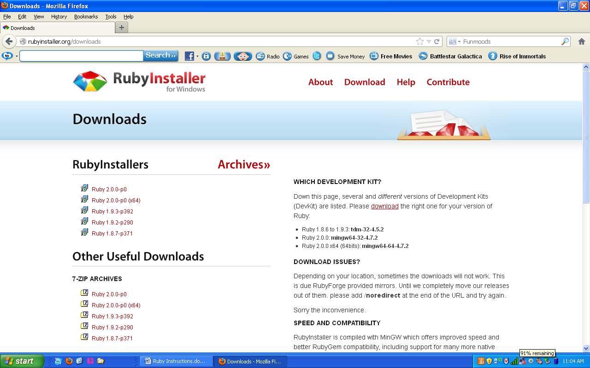Go to <http://rubyinstaller.org/downloads>

Click and download “Ruby 1.9.3-p392”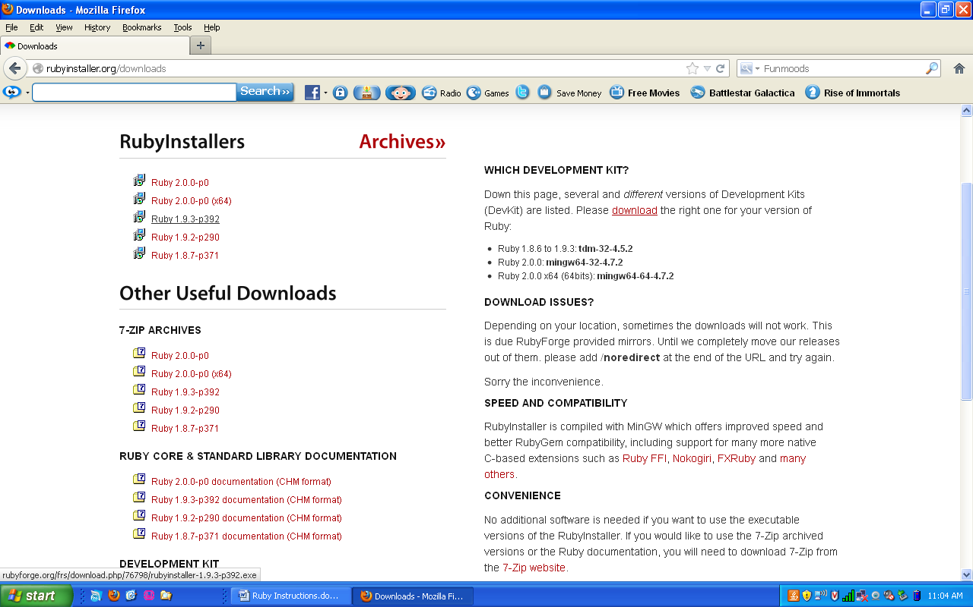

Screenshot of Ruby 1.9.3-p392 downloading. When the file downloads, it is called rubyinstaller-1.9.3-p392.exe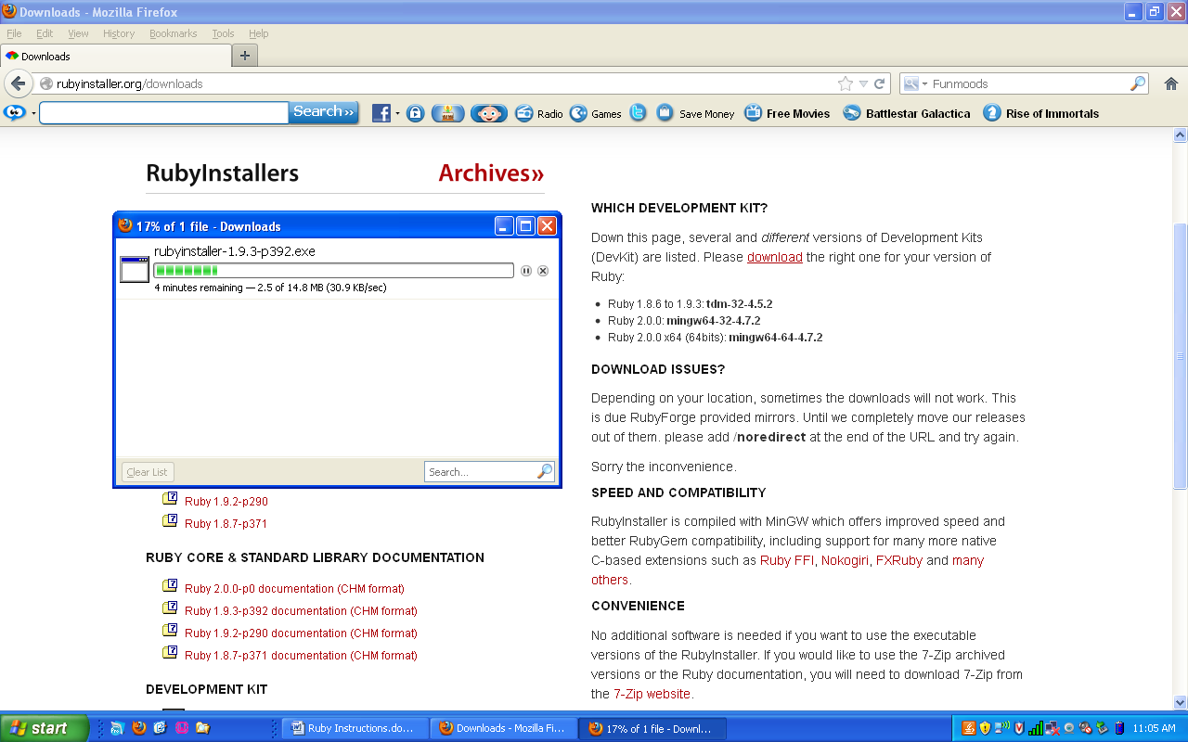

Navigate to your downloads folder.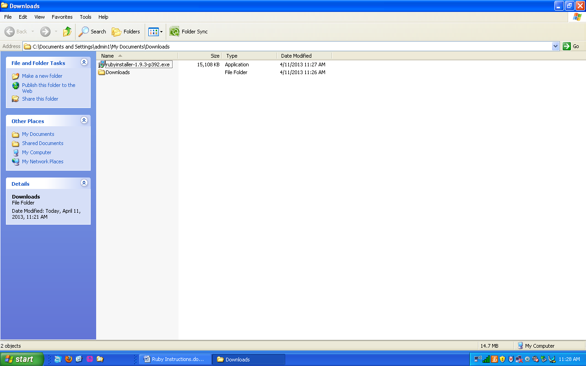

Double click on rubyinstaller-Ruby 1.9.3-p392.exe and click on Run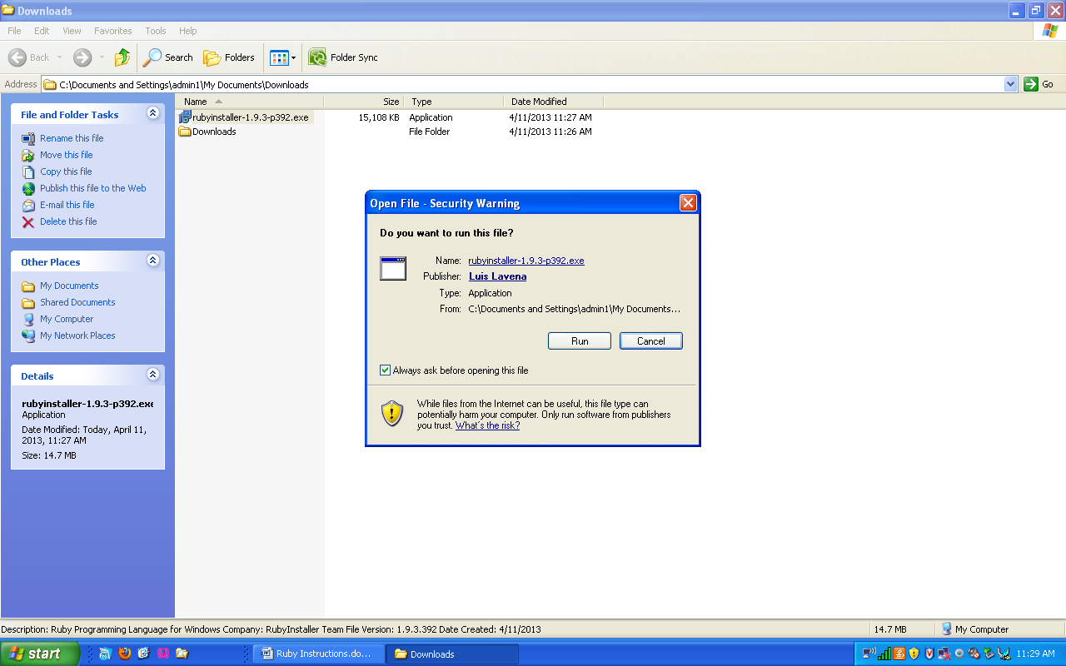

The installer will let you pick a language, default is English. Click ok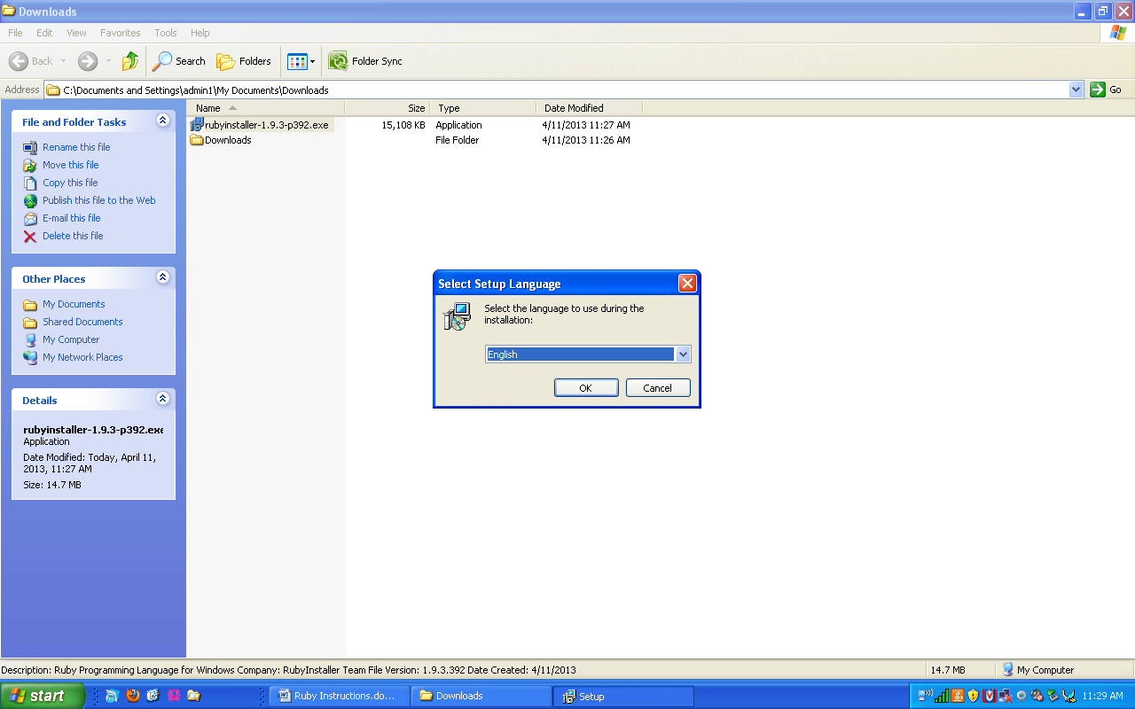

On this screen click “I accept the License”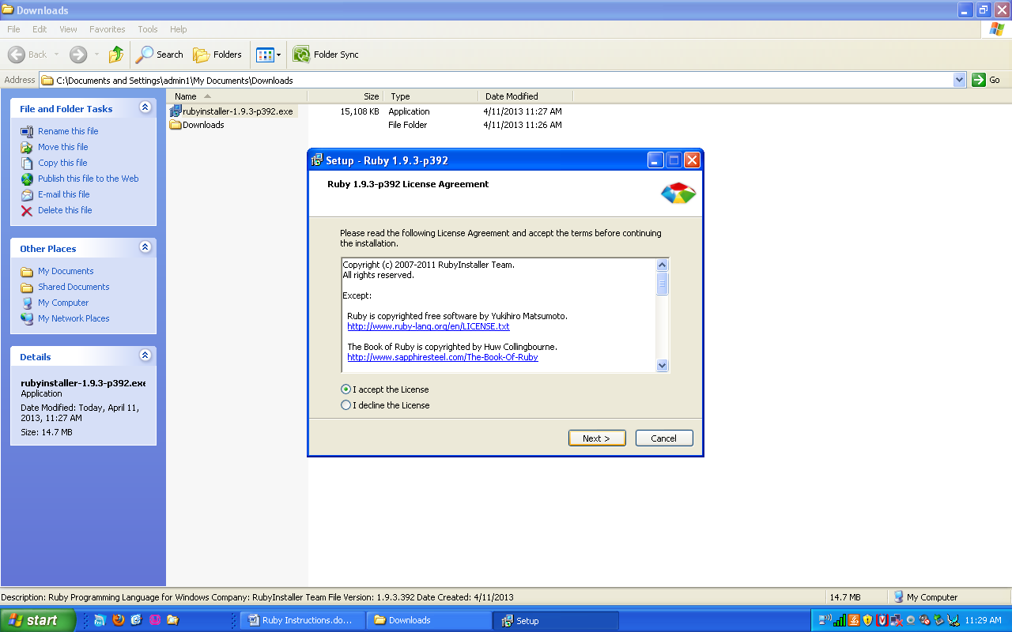

Next click on the three options that you are allowed to choose from. “install Tcl/Tk support”, “Add Ruby executables to your PATH”, “Associate .rb and .rbw files with this Ruby installation”. Then click on Install.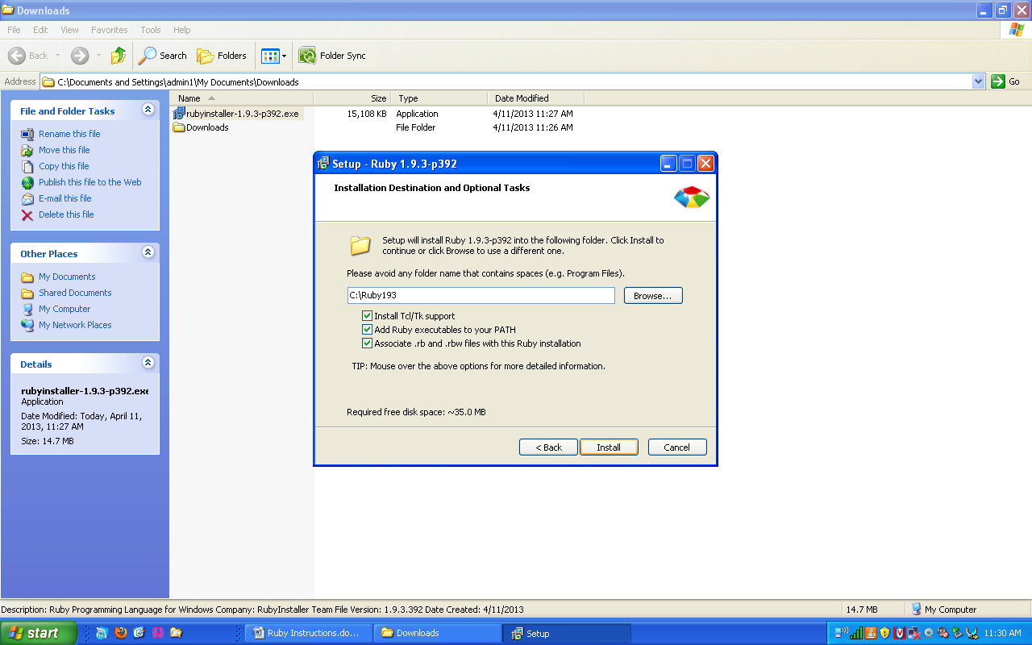

Ruby 1.9.3-p392 will now install. When it is done click on Finish.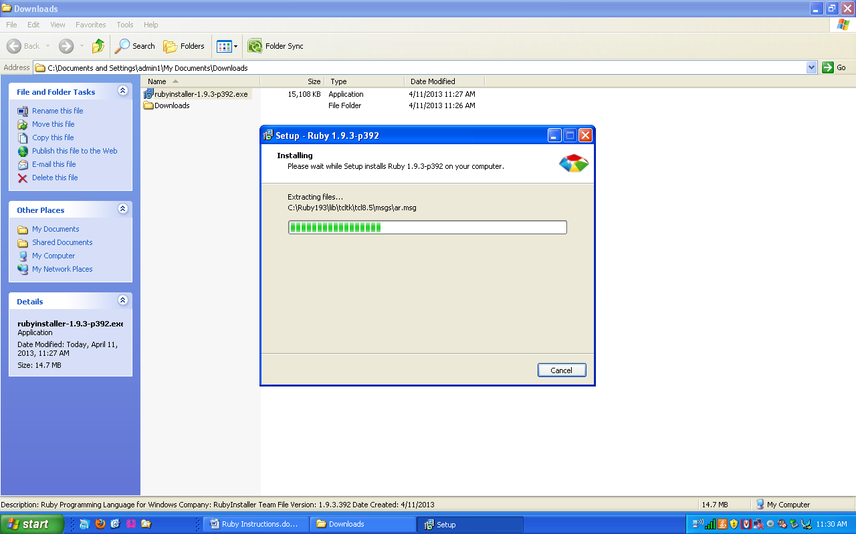

Next go to <http://rubyinstaller.org/downloads> and click on DevKit-**tdm**-32-4.5.2-20111229-1559.exe

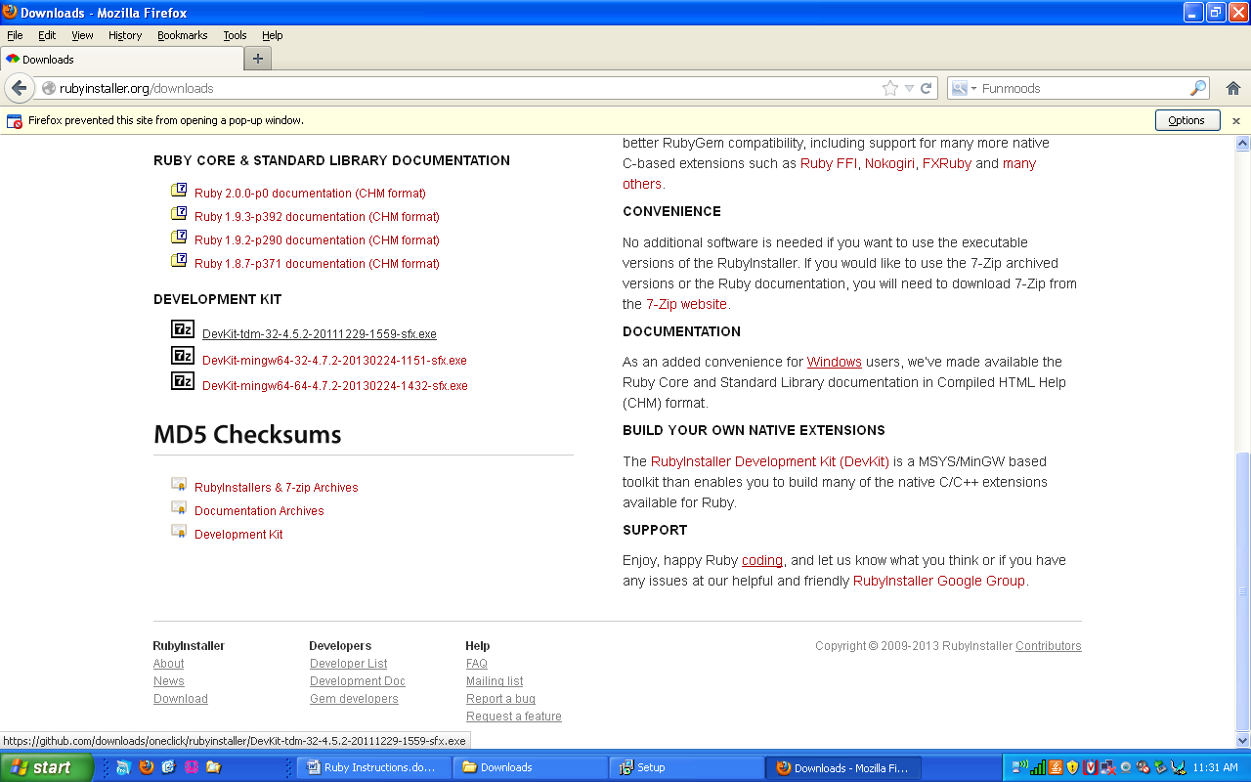

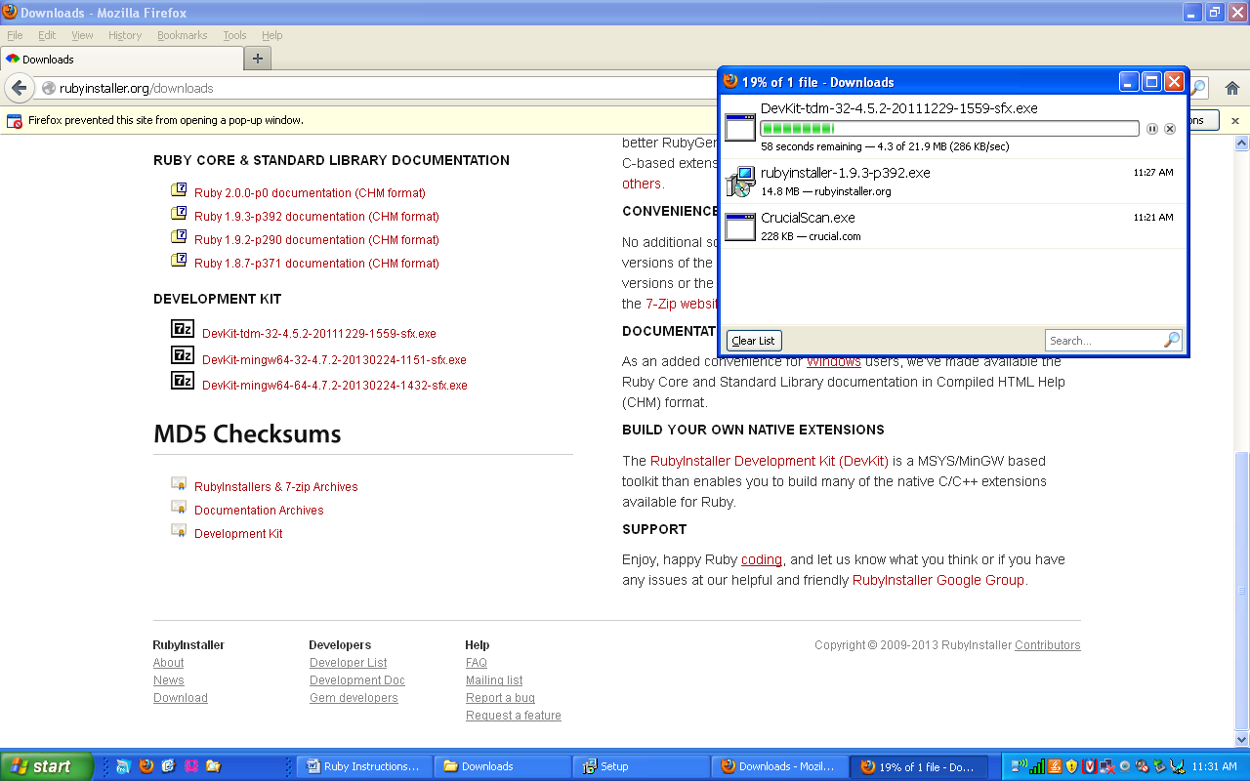

Next navigate to your C drive: C:\  
Create a new Folder and name it “Devkit”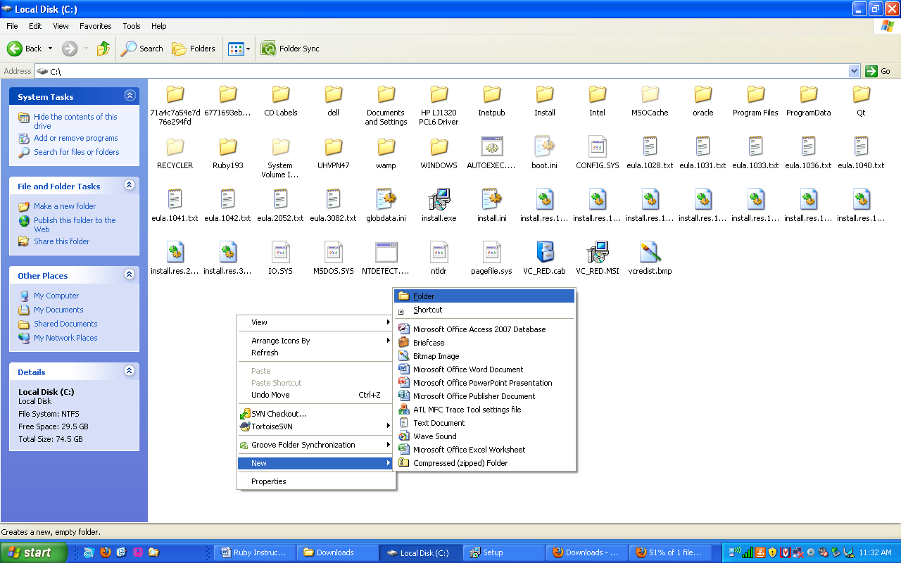

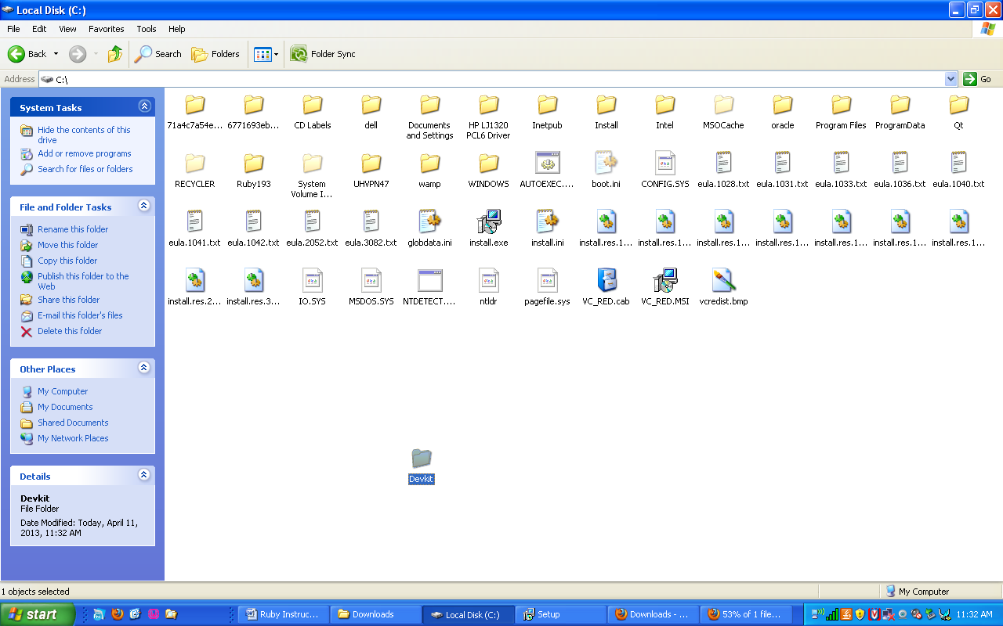

Now navigate to your downloads folder and open DevKit-**tdm**-32-4.5.2-20111229-1559.exe and click on run.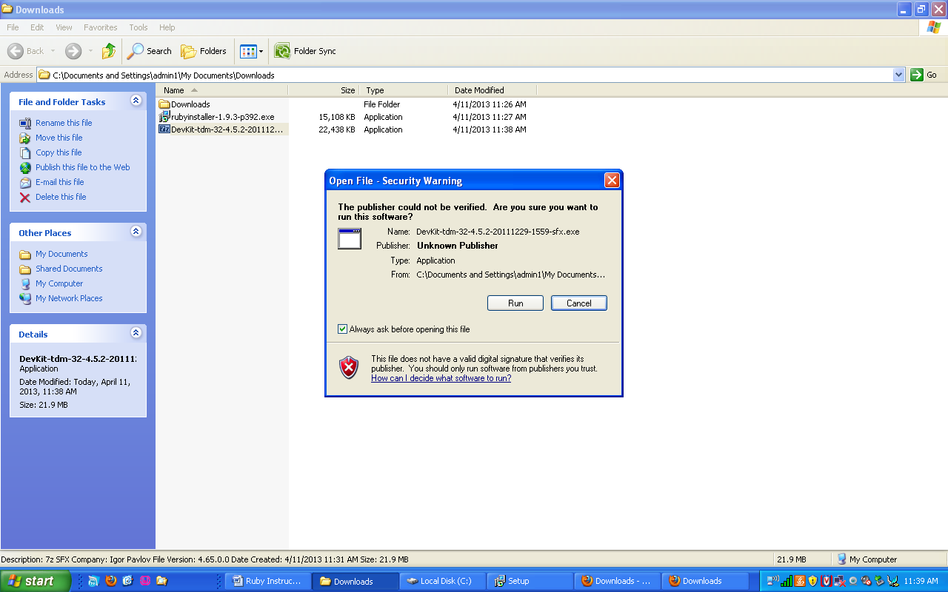

Click on the “…”, In the dropdown that appears, click on Local Disk (C:), then click on the new folder you created “Devkit”. Then click on ok.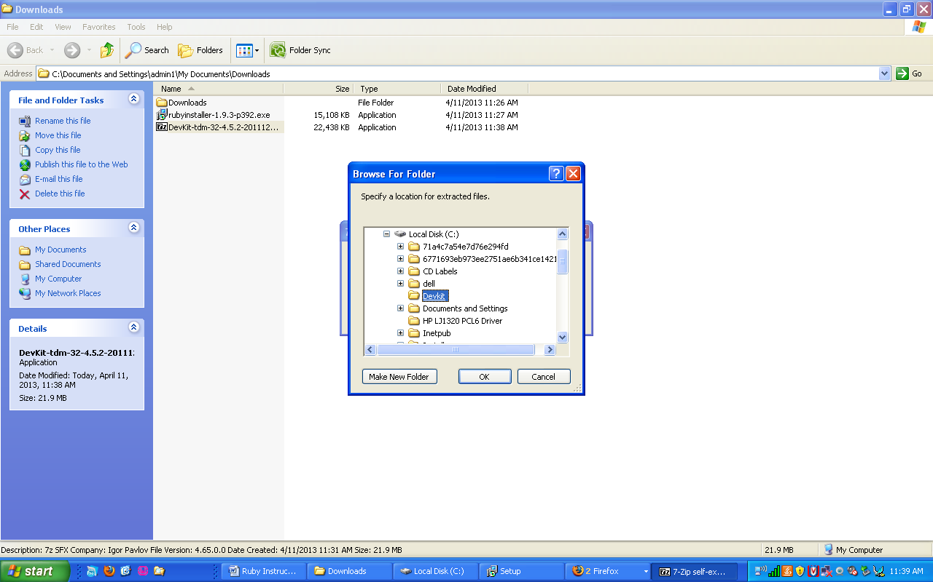

The location to extract to should look like this: C:\Devkit  
Then Click on Extract  
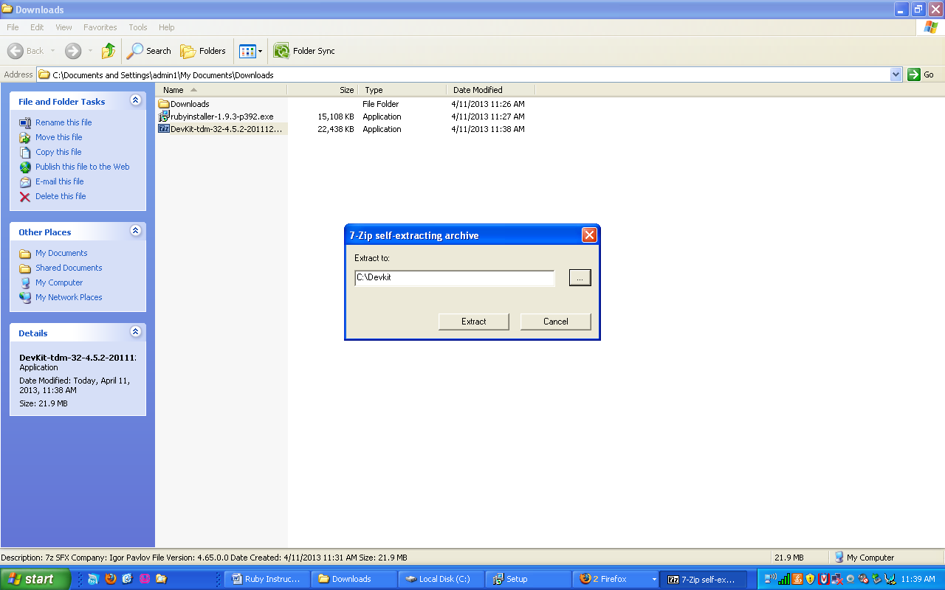

Screenshot of DevKit-**tdm**-32-4.5.2-20111229-1559.exe extracting.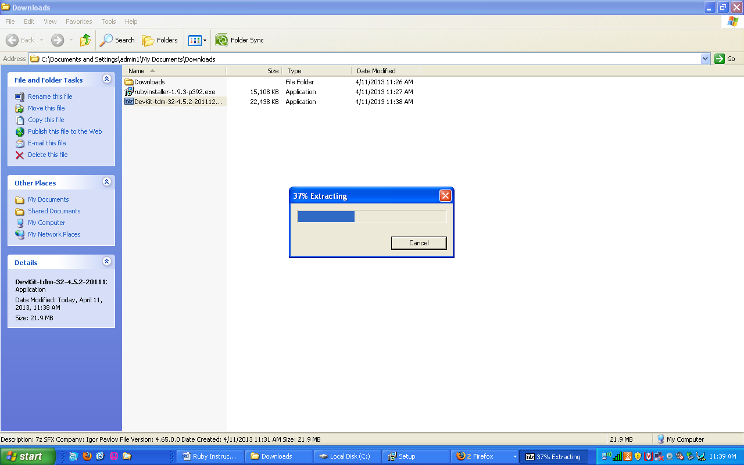

Next type “windows key + r”, in the run prompt that appears, type “cmd”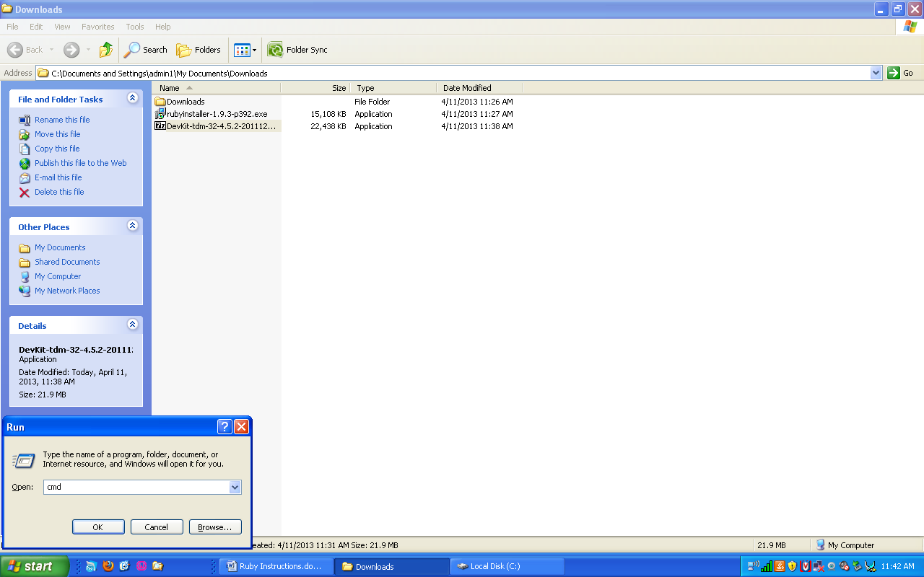

Next you need to navigate to the C Drive. Type “cd \”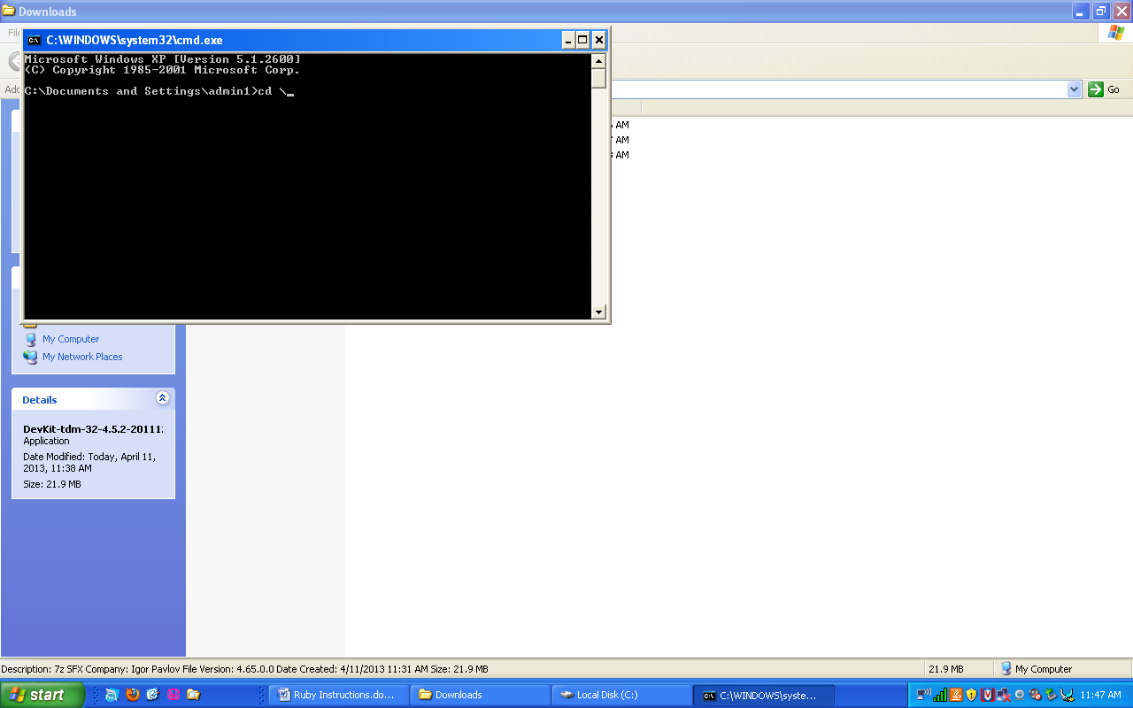

Now navigate to the Devkit folder you created. Type “cd Devkit”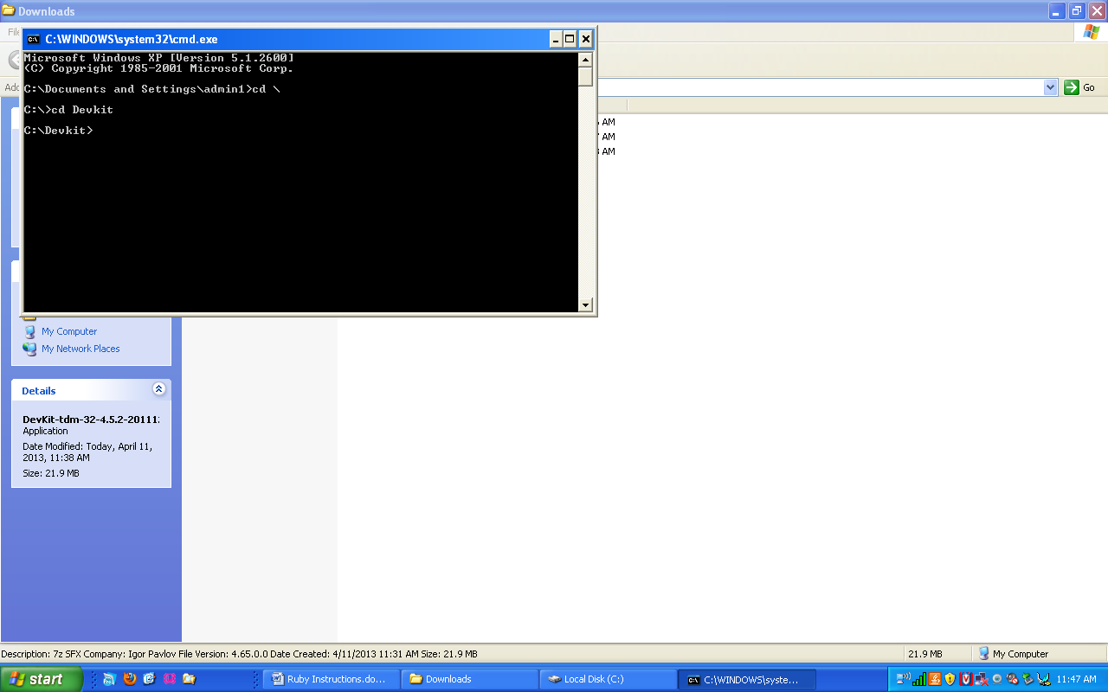

Next type “ruby dk.rb init” This will initialize the installation and locate your ruby installation.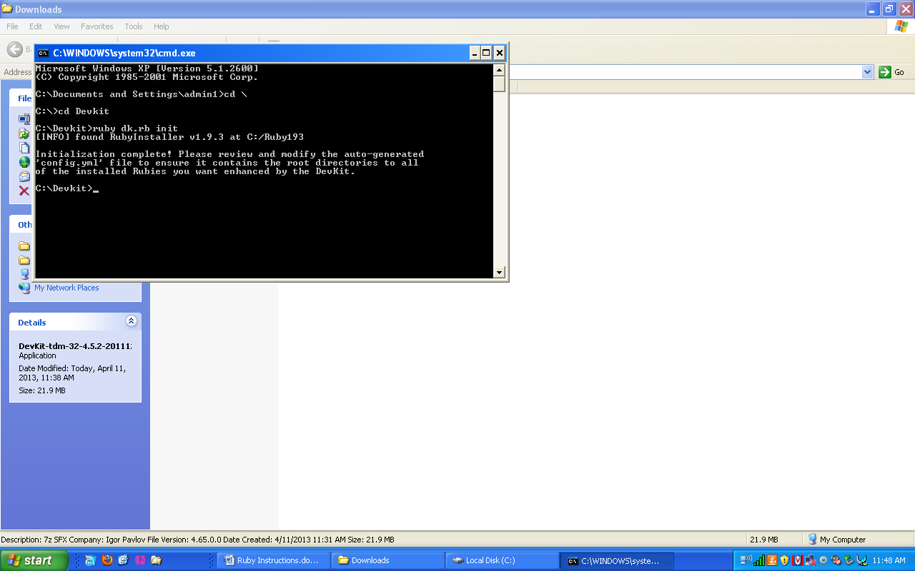

There are two ways to make sure it located your installation correctly. First way is you can Navigate to C:\Devkit and open the file config.yml in notepad. And check that your ruby location says: C:/Ruby193

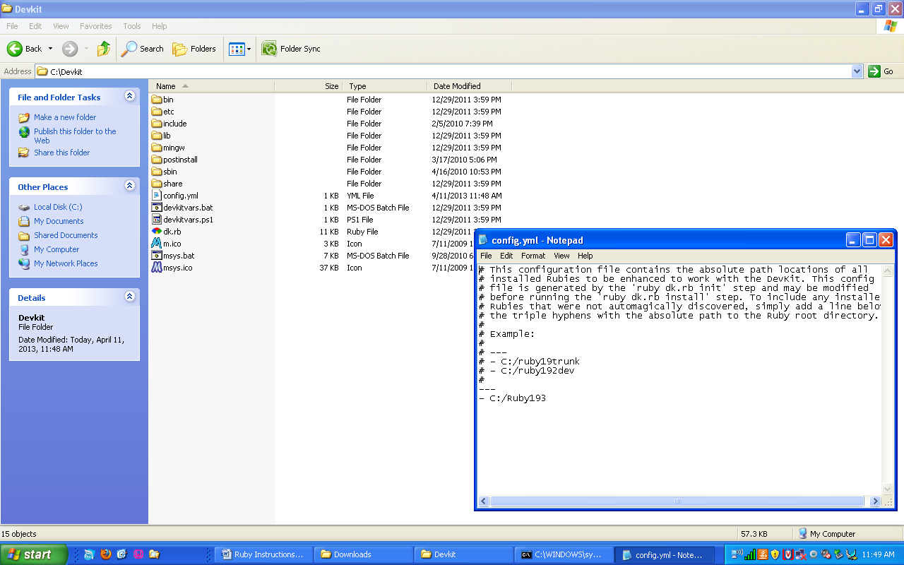

Second way to check if your ruby installation is located , is in the console type ruby dk.rb review. It should list your ruby installation C:/Ruby193

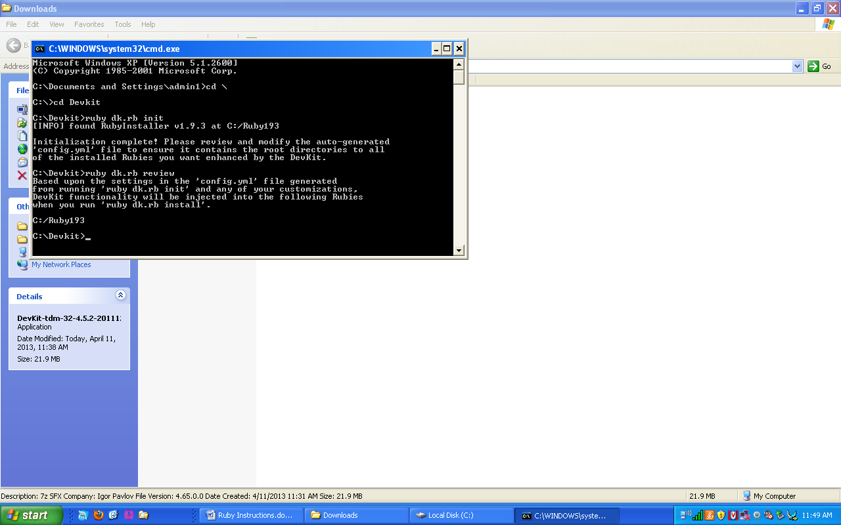

Next install the Devkit by typing “ruby dk.rb install”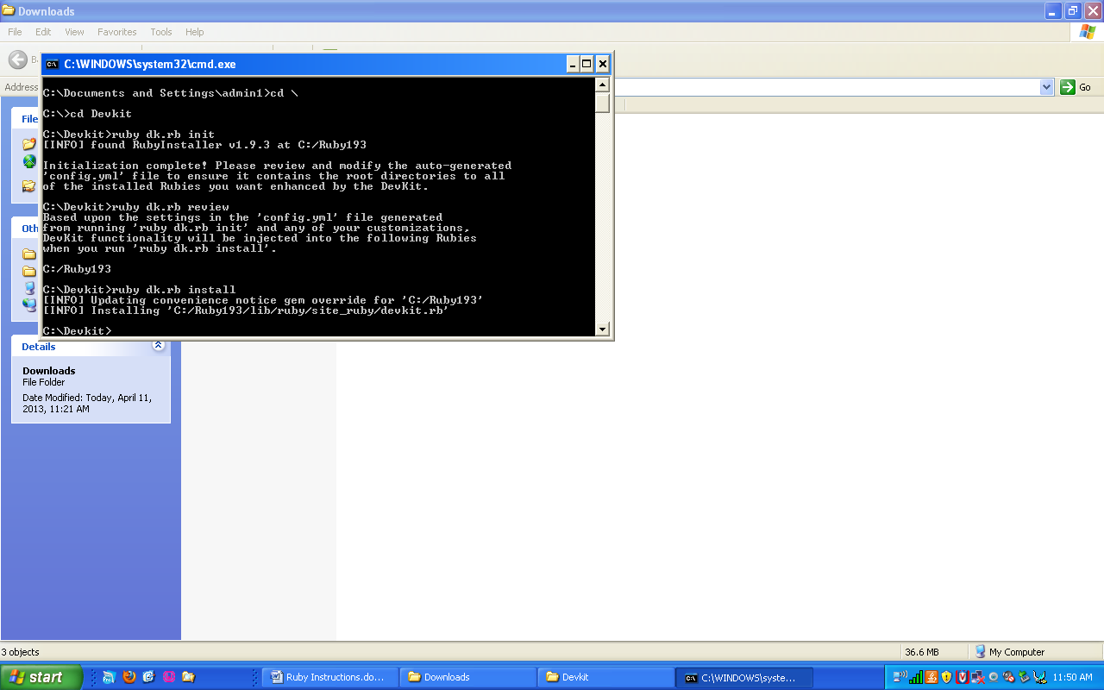

To check that the installation worked, type “gem install json --platform=ruby”.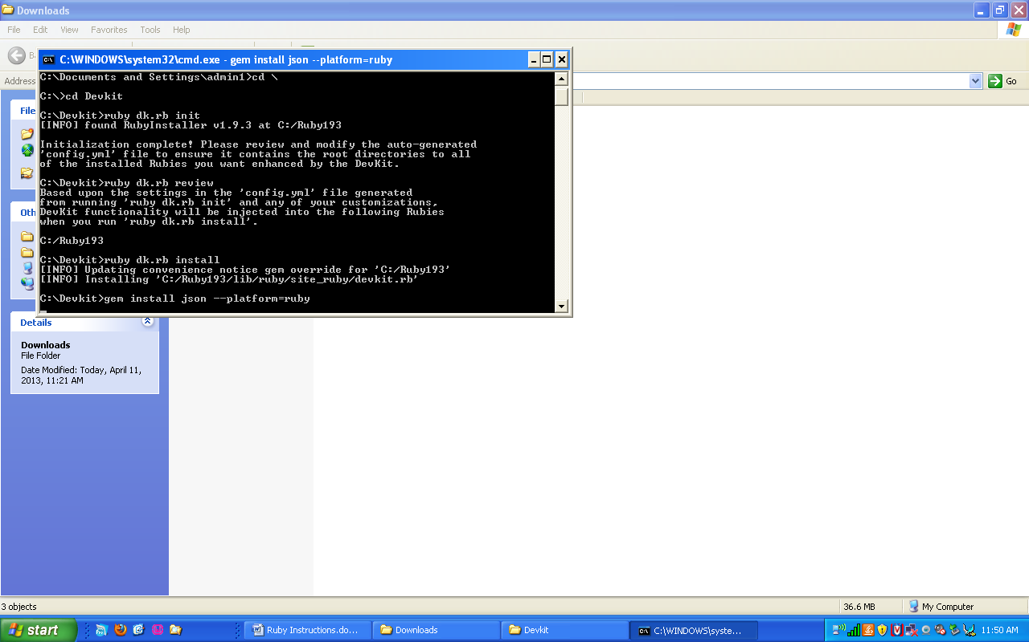

It should successfully install the gem if ruby and the devkit are installed correctly.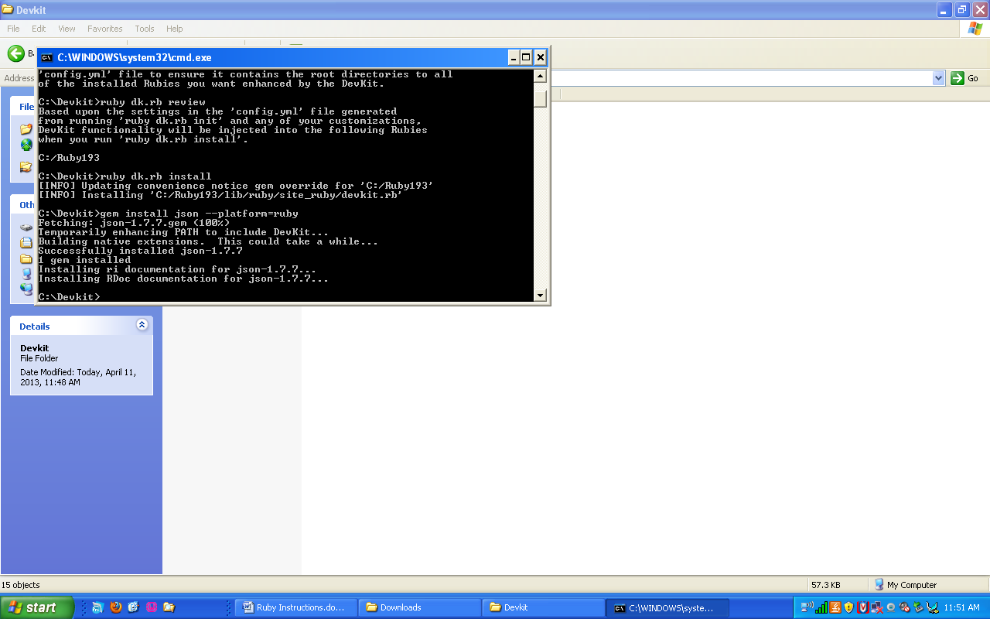

Type “exit” to leave the console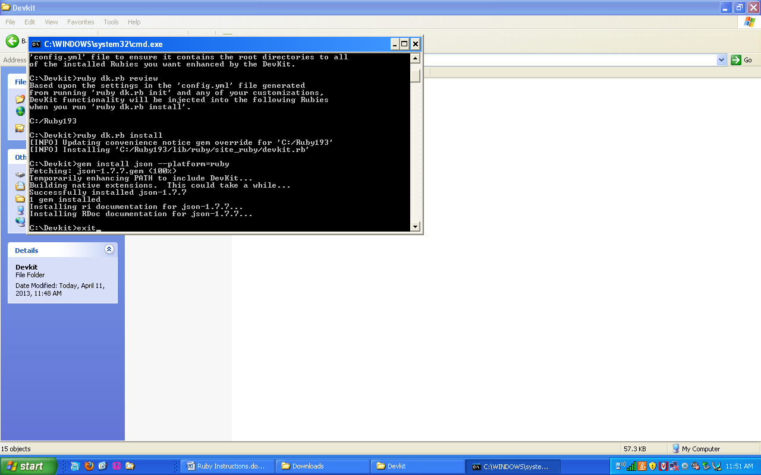

Next go to <http://www.jetbrains.com/ruby/download> and click on “Get RubyMine 5.4 Now”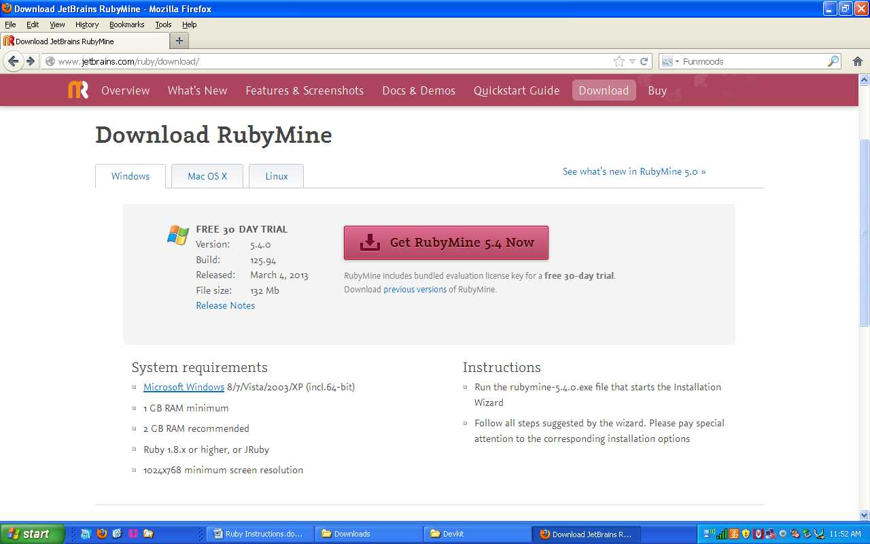

Screenshot of RubyMine Downloading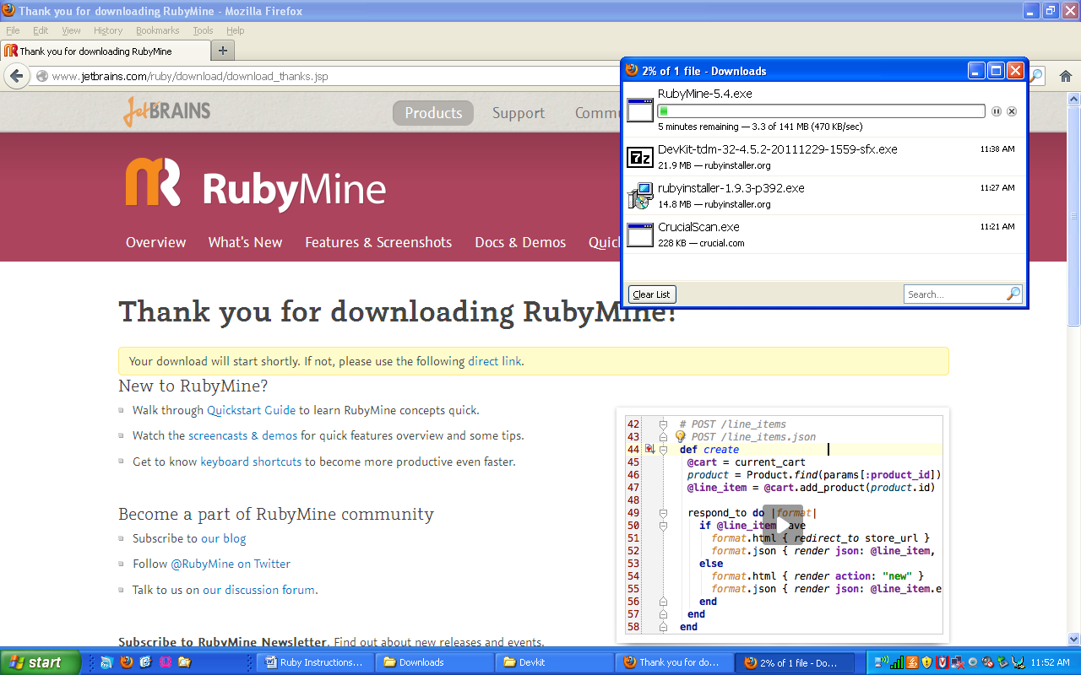

Next navigate to your downloads folder and open RubyMine-5.4.exe and click on run.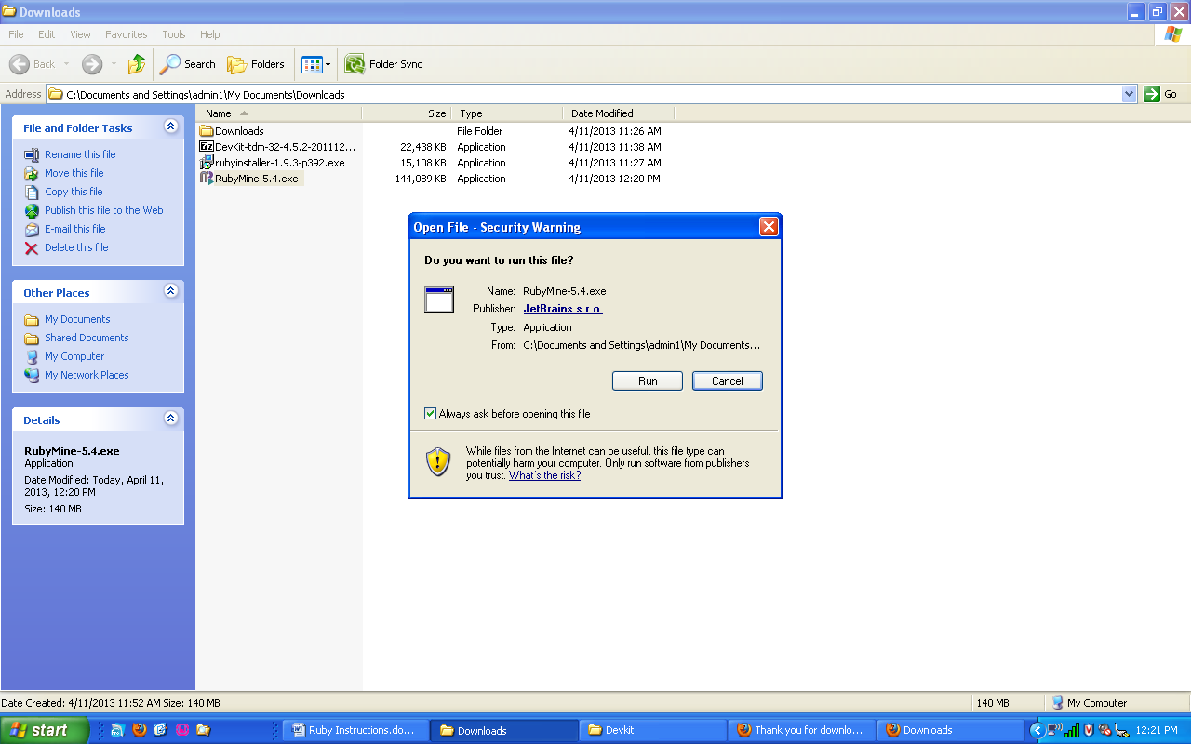

Click on Next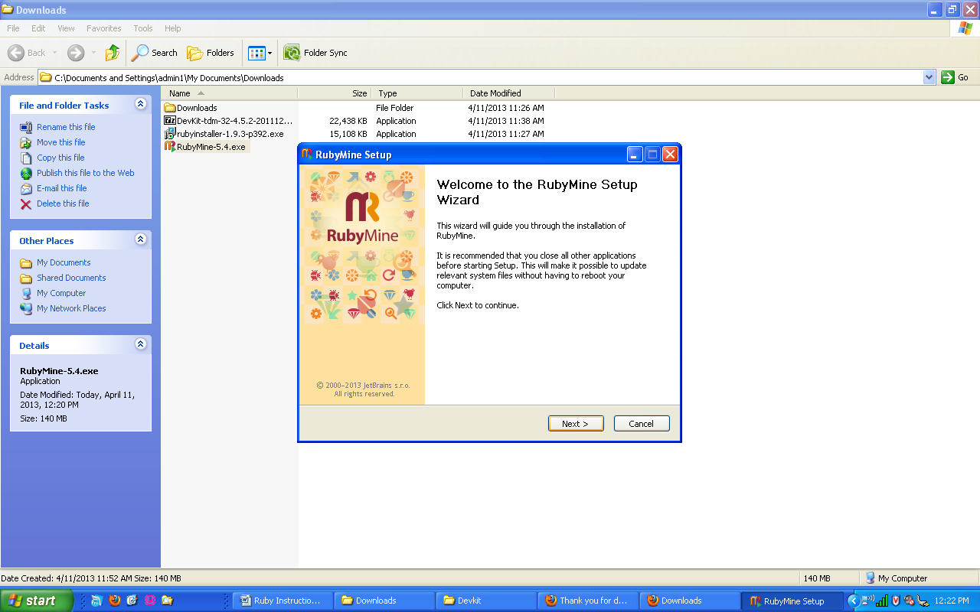

Click on I agree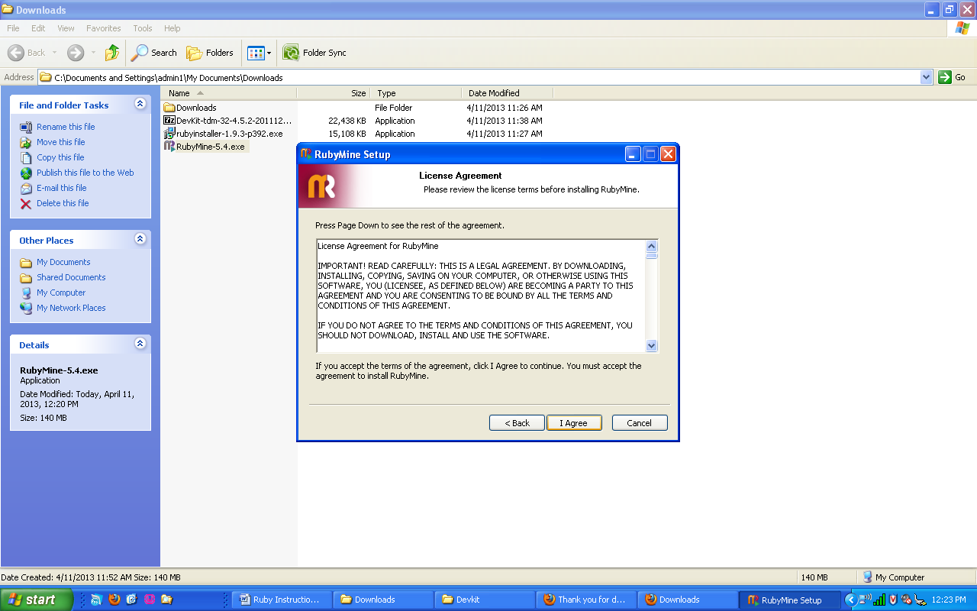

Leave the default installation, and click on next.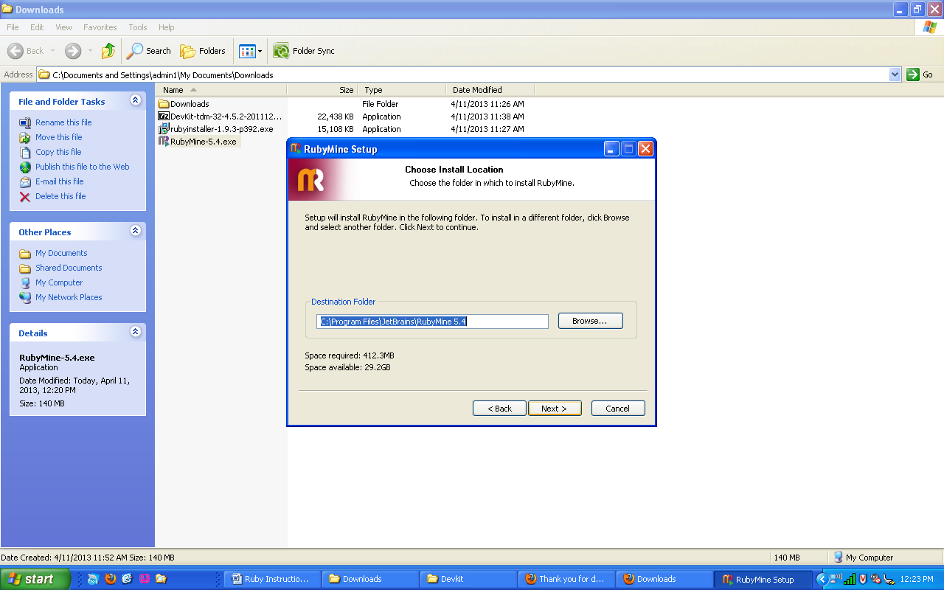

Click on Create Desktop Shortcut and Create Quick Launch shortcut then click on next.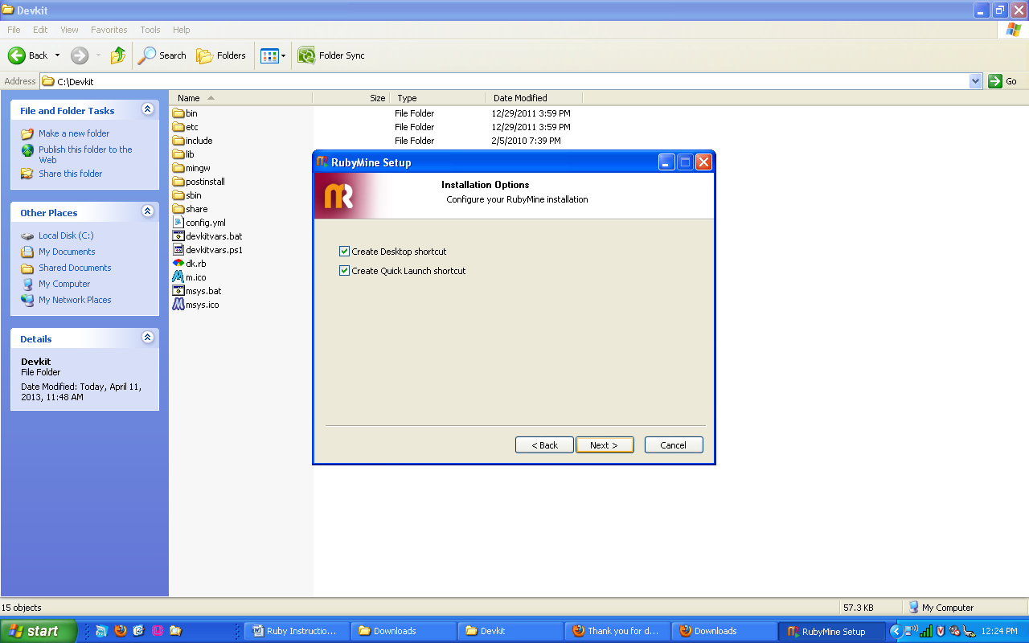

Leave the name JetBrains and click on next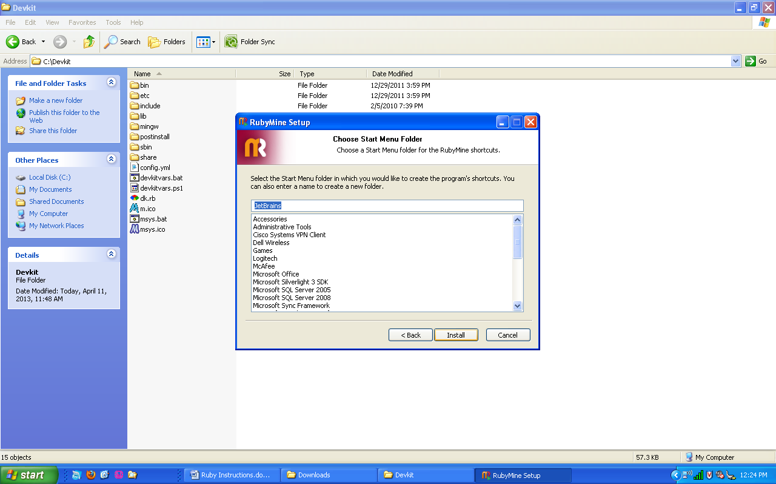

Screenshot of RubyMine installing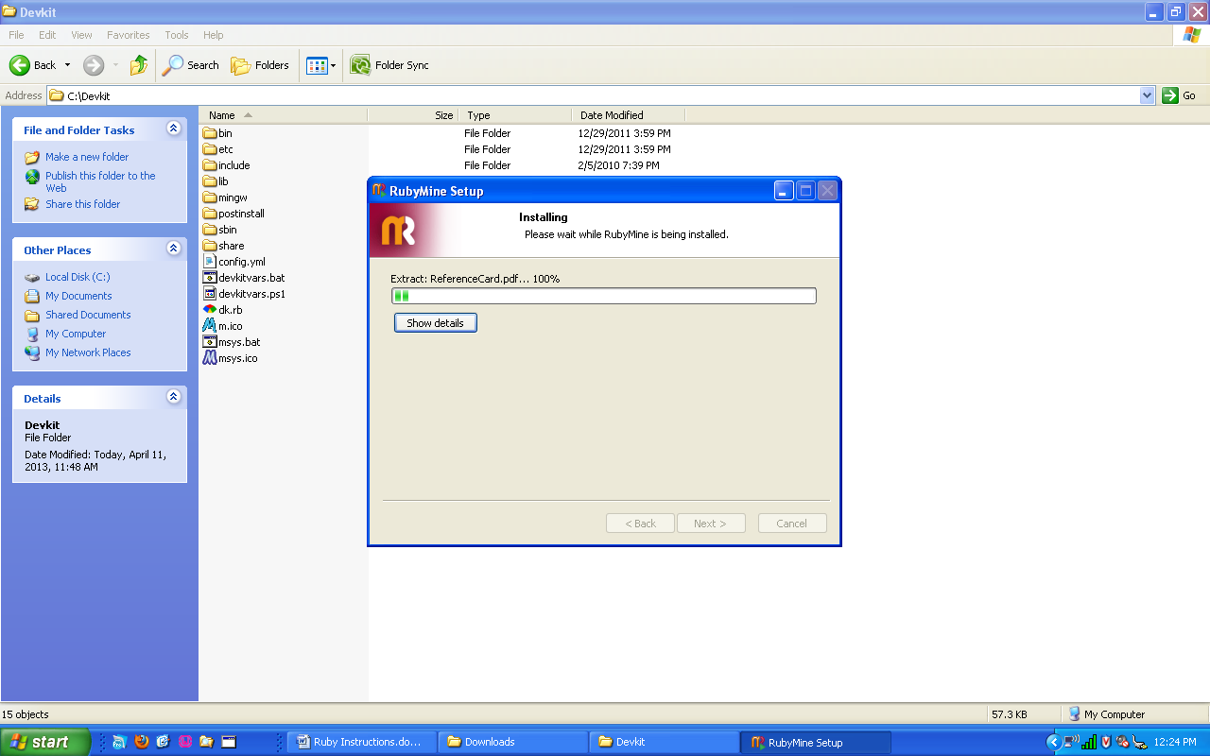

When it is done installing, click on Run RubyMine and click on finish.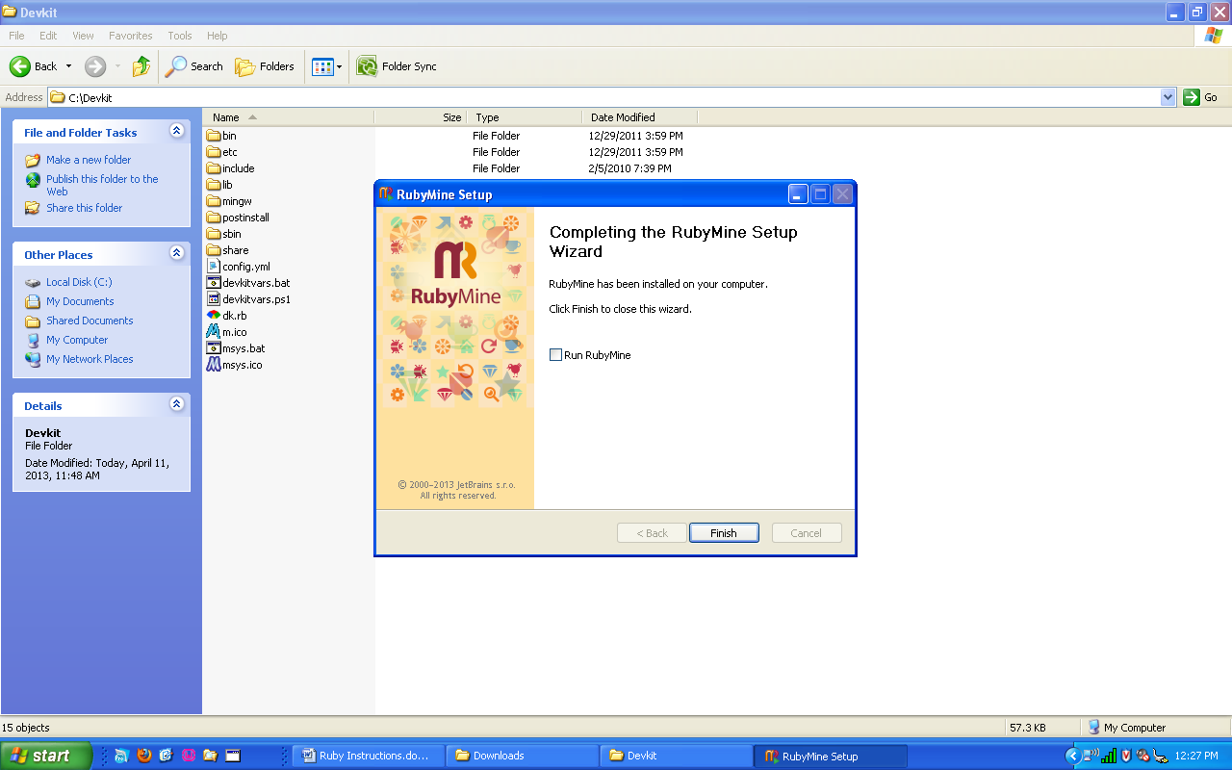

When RubyMine opens for the first time, you need to choose “I do not have a previous version of RubyMine or I do not want to import settings” then click on ok.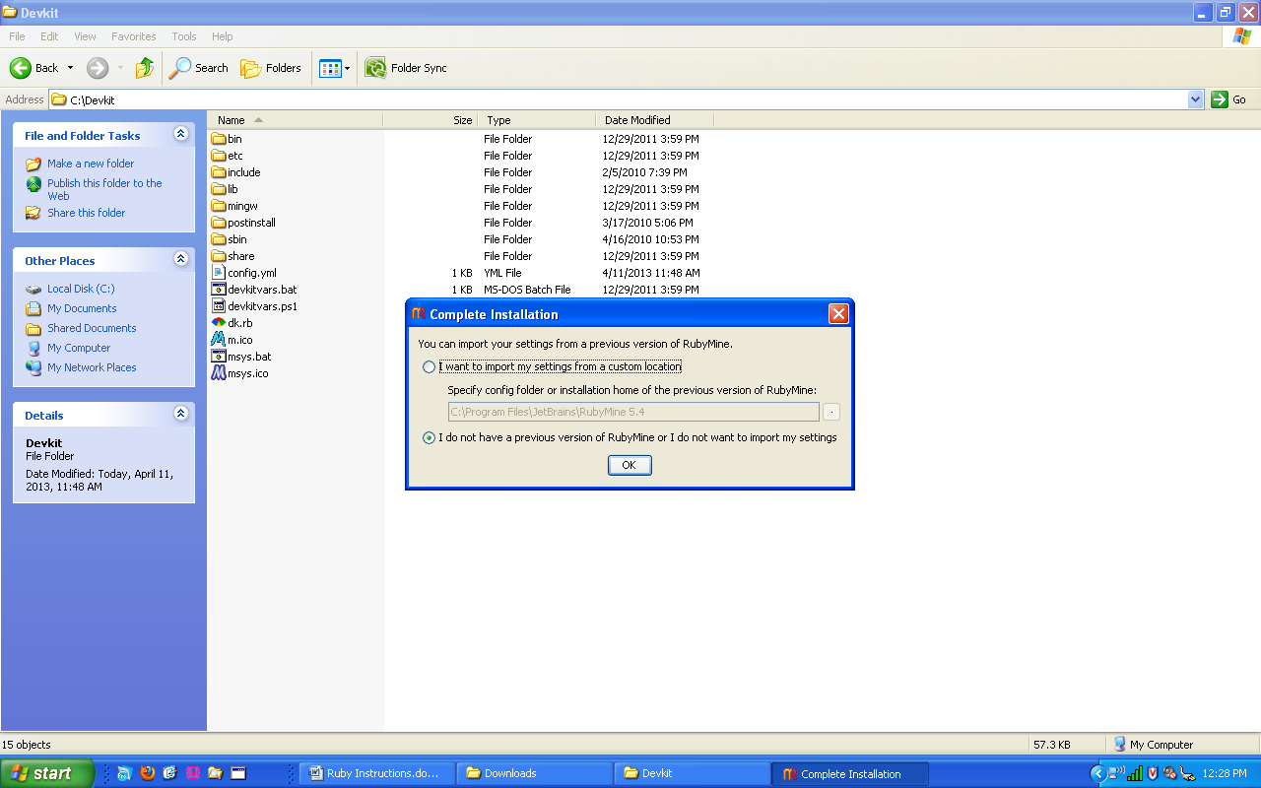

Click on “Evaluate for free for 30 days”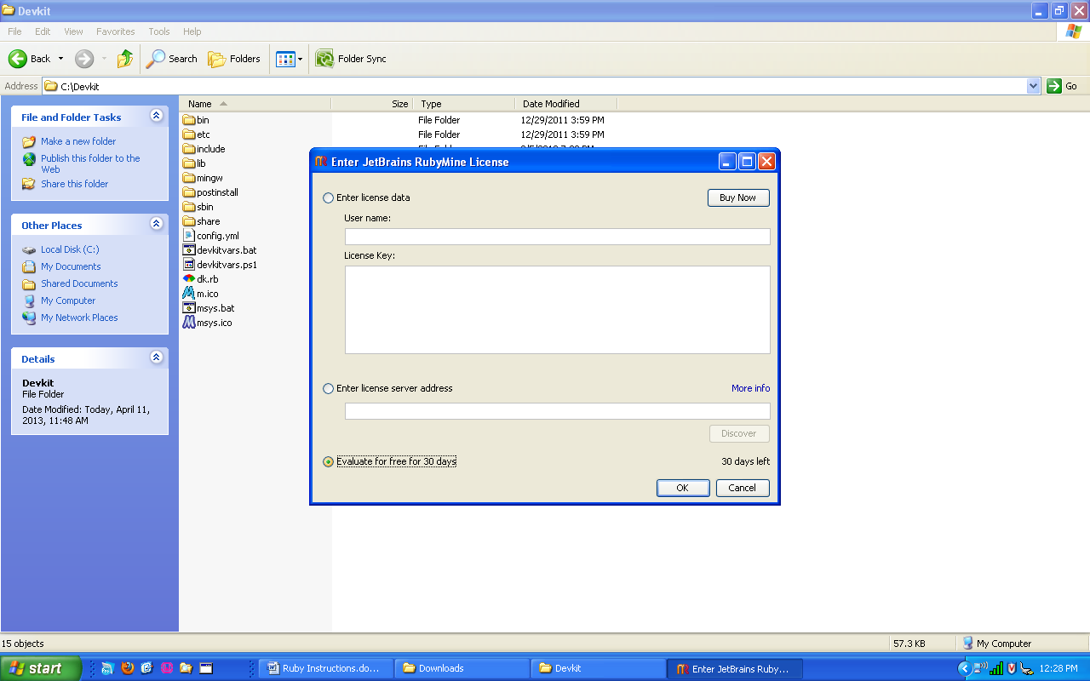

Click on “Accept all terms of the license” and click on ok.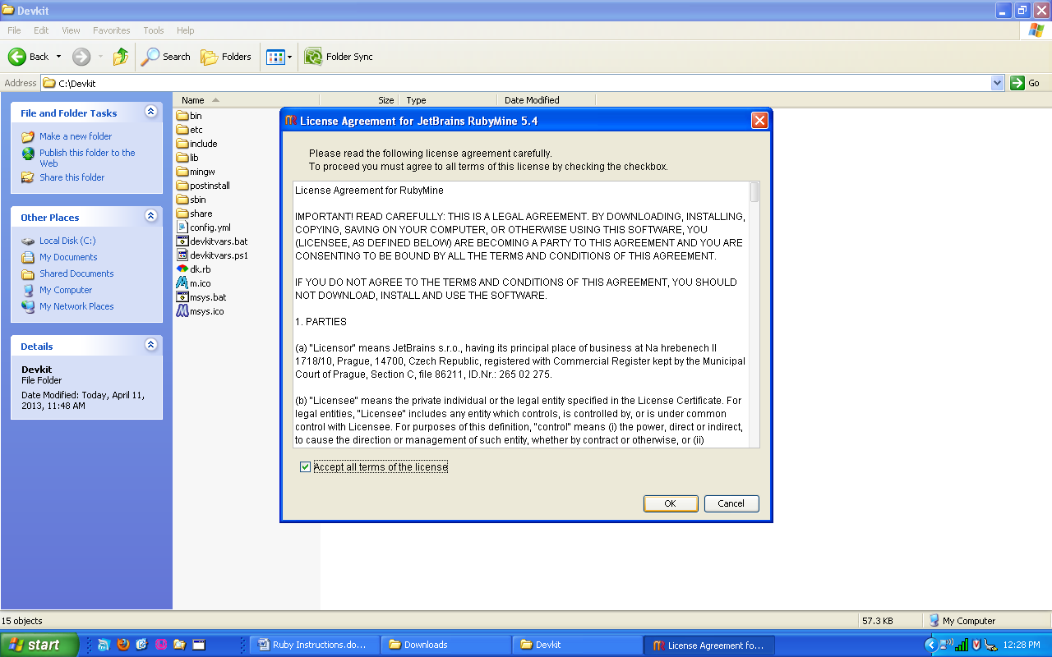

Leave the initial configuration as is and click on ok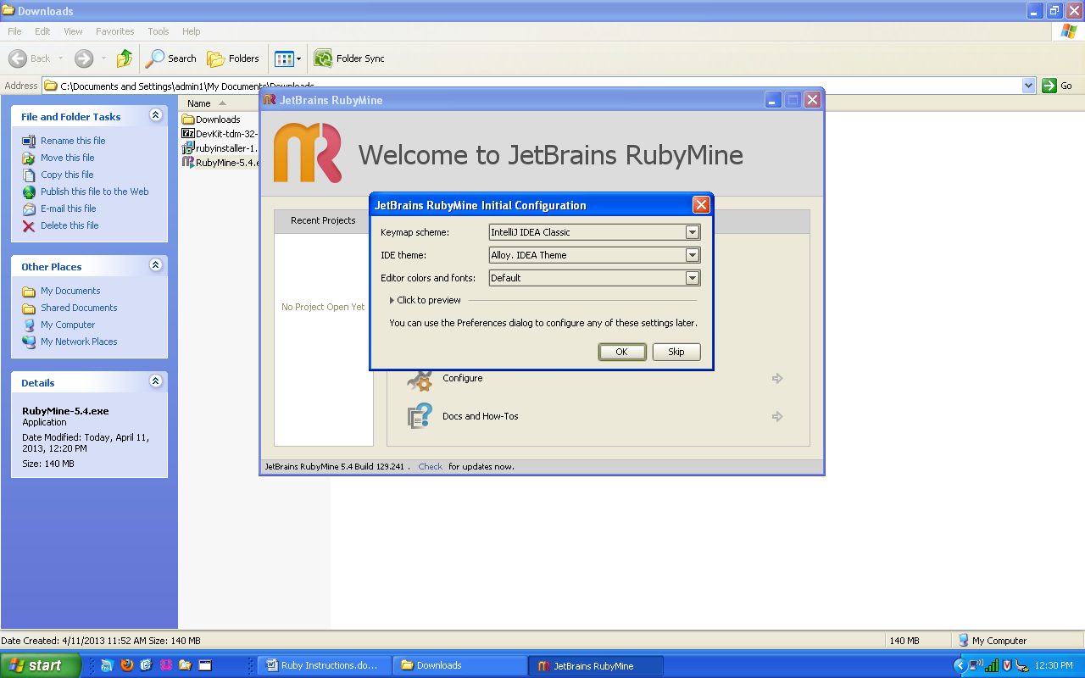

**Specific to TEAM5OAGS Project**

Next you will click on Open Directory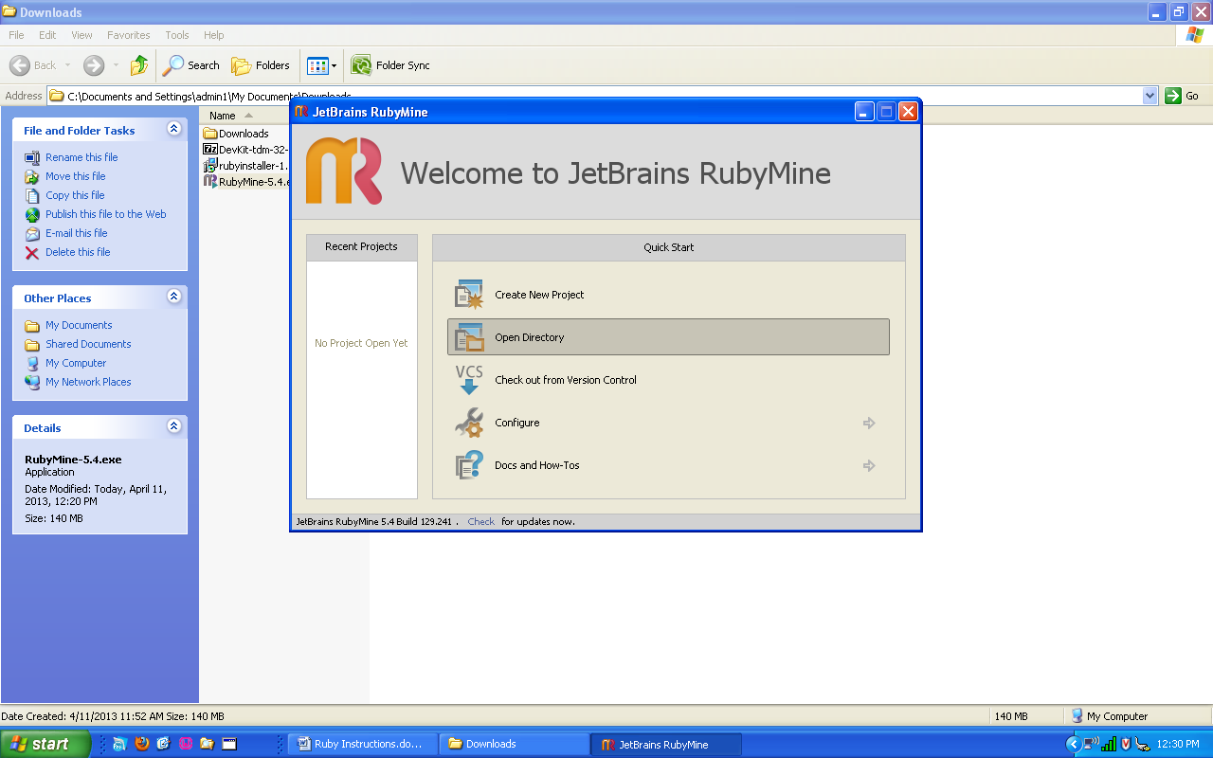

For this tutorial, our svn folder was checked out to a folder on the Desktop named TEAM5OAGS. Locate the folder in the path menu. C:\Documents and Settings\admin1\Desktop\TEAM5OAGS\TEAM5OAGS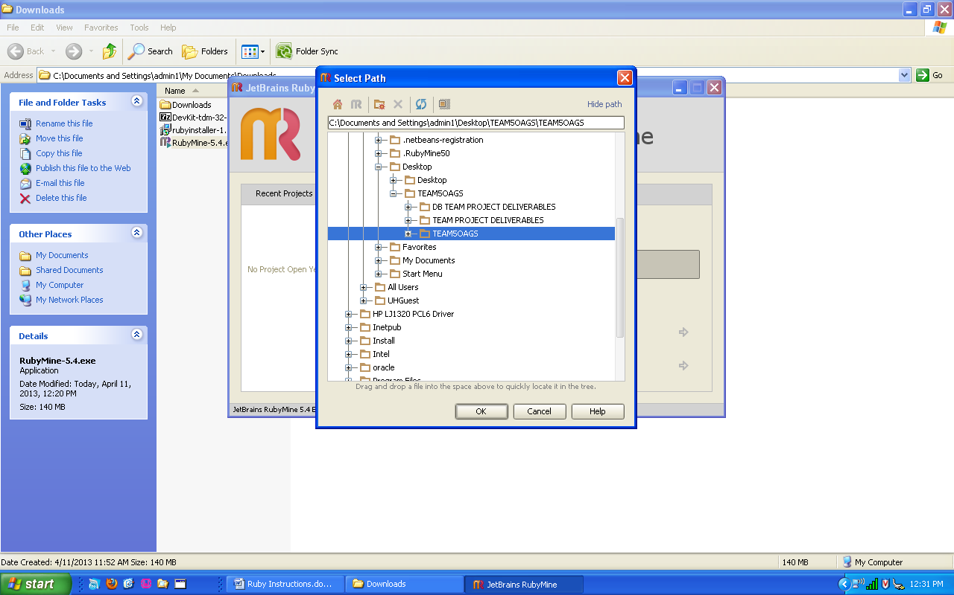

If the windows security alert or firewall warning appears, click on unblock, or allow access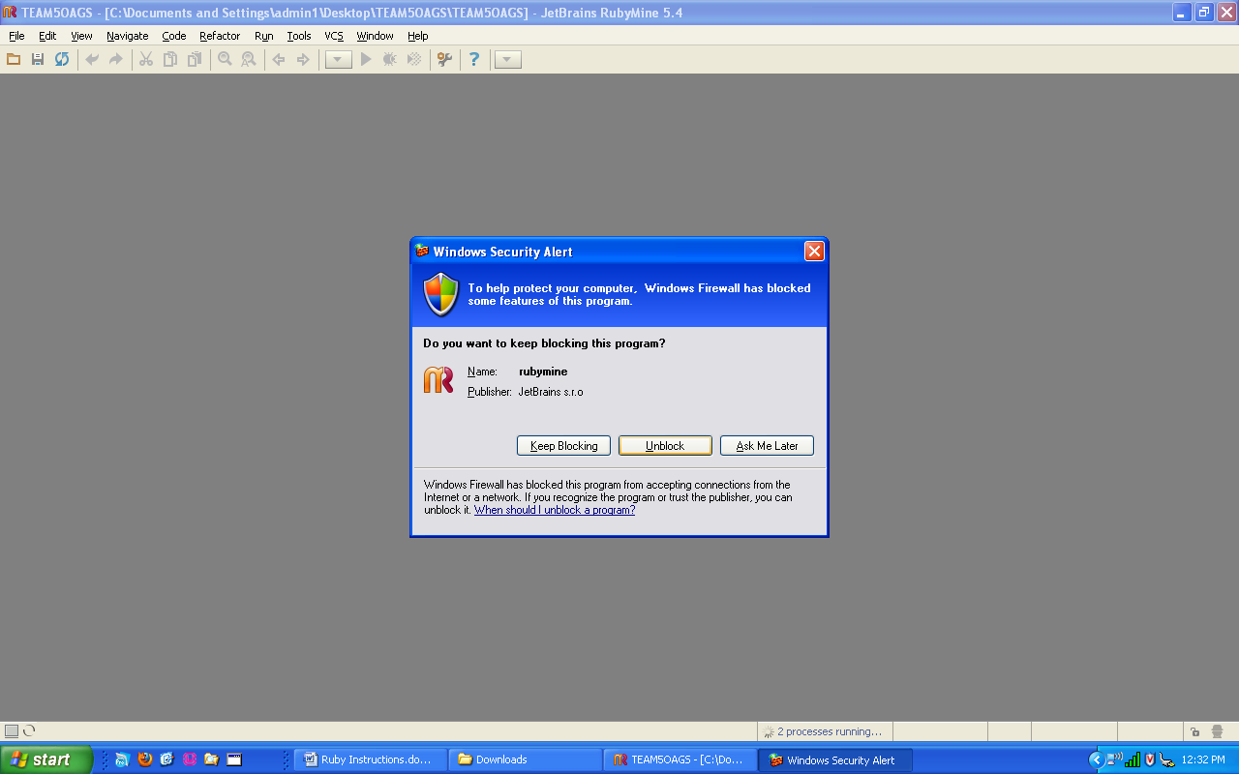

Click on close to remove the tip of the day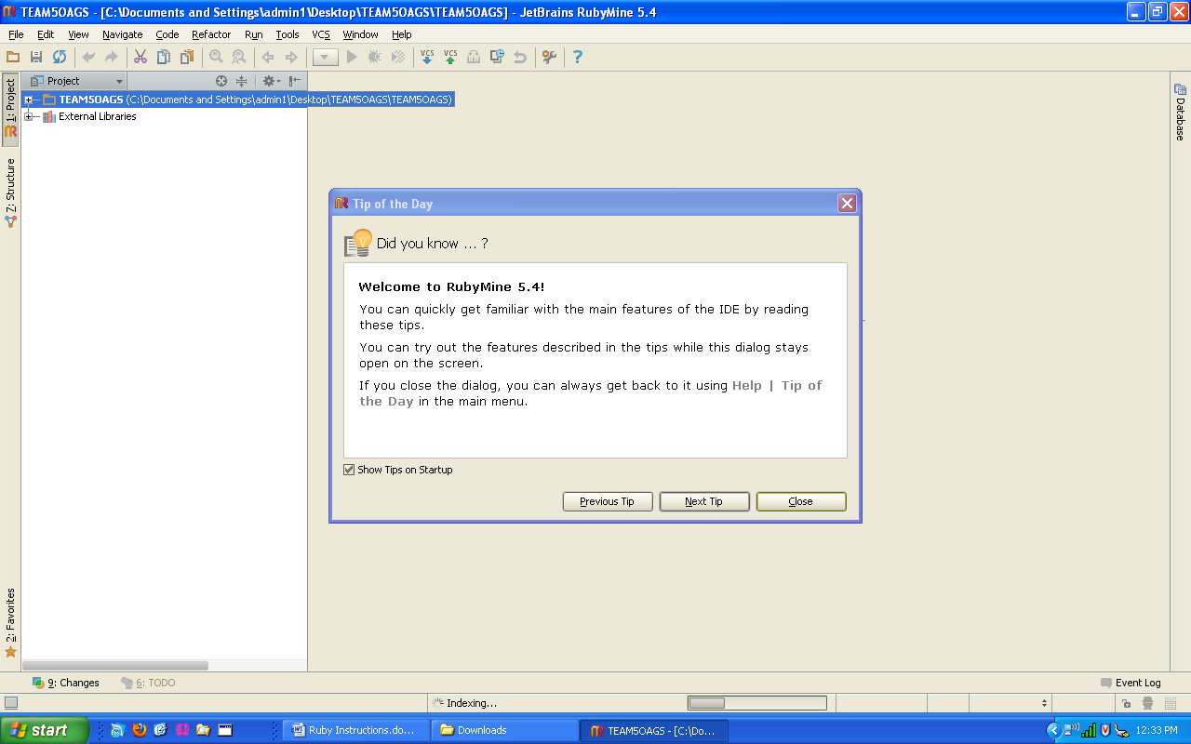

RubyMine has to be configured the first time you try to work in it, ignore the warnings in green and yellow that are popping up for now. Go to File🡪Settings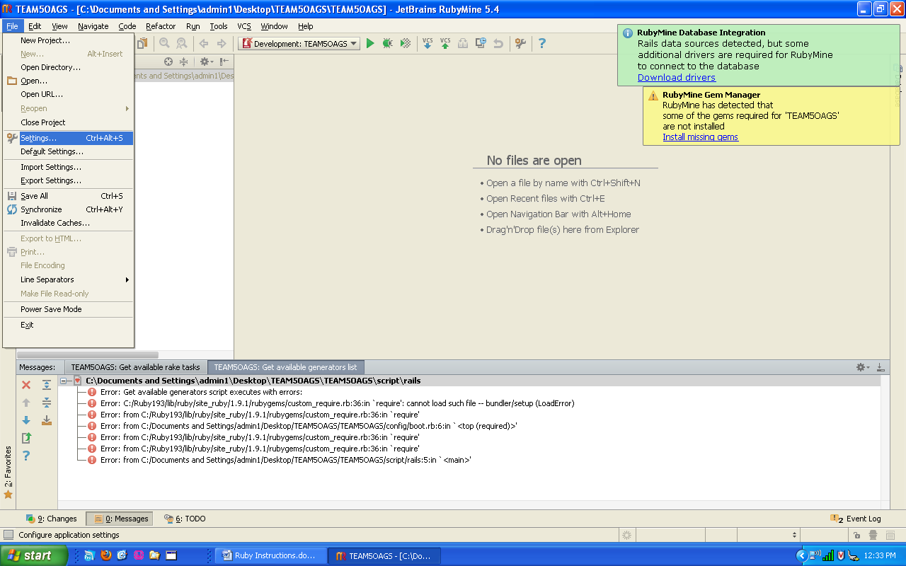

Click on Ruby SDK and Gems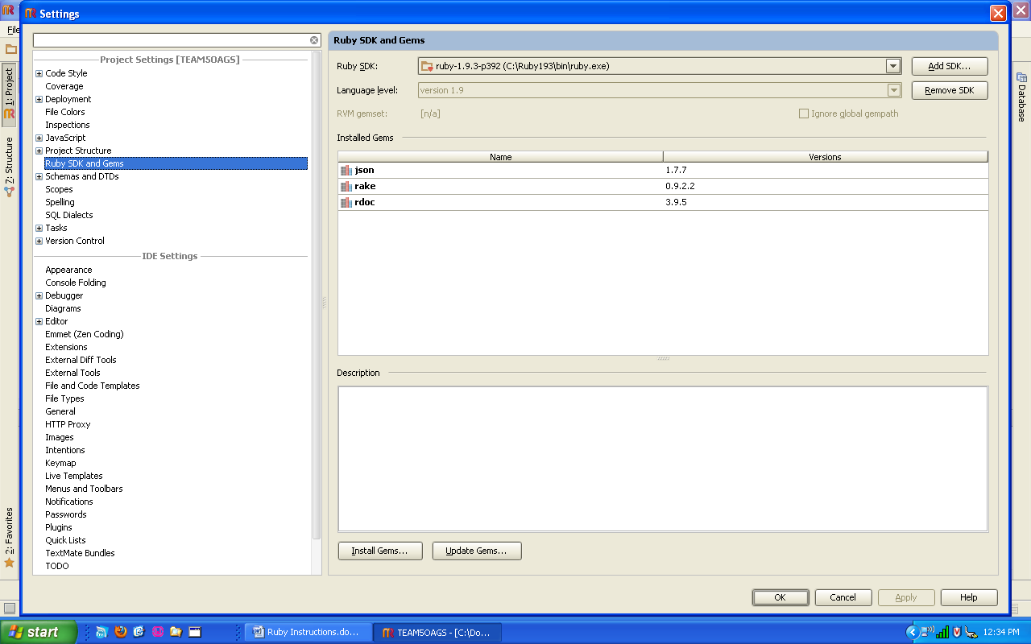

Then click on Install Gems…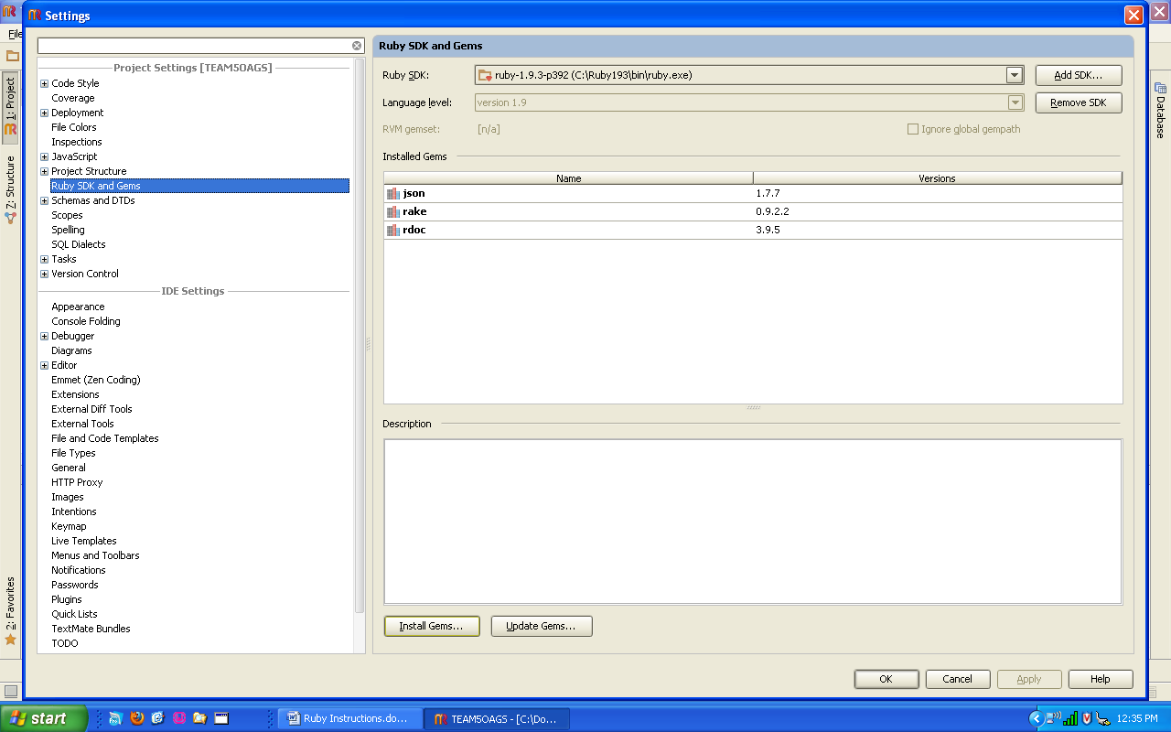

In the list of gems, search for rails and select it.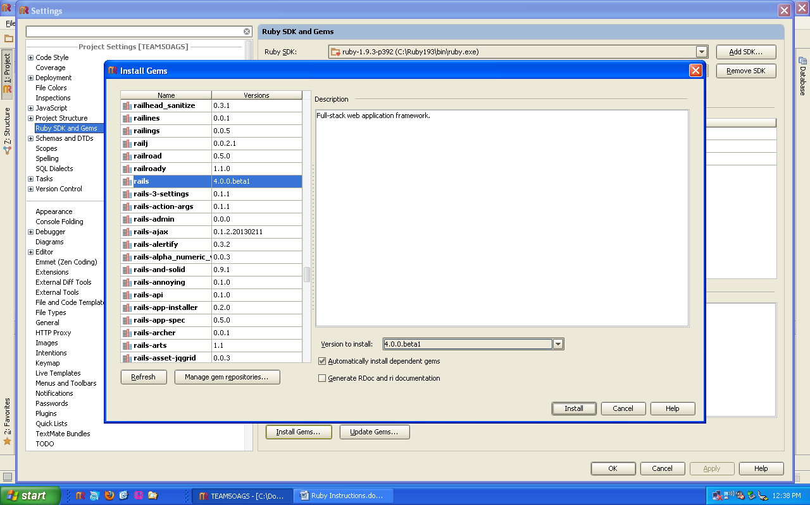

Under Version to Install, look for 3.2.12 and select it.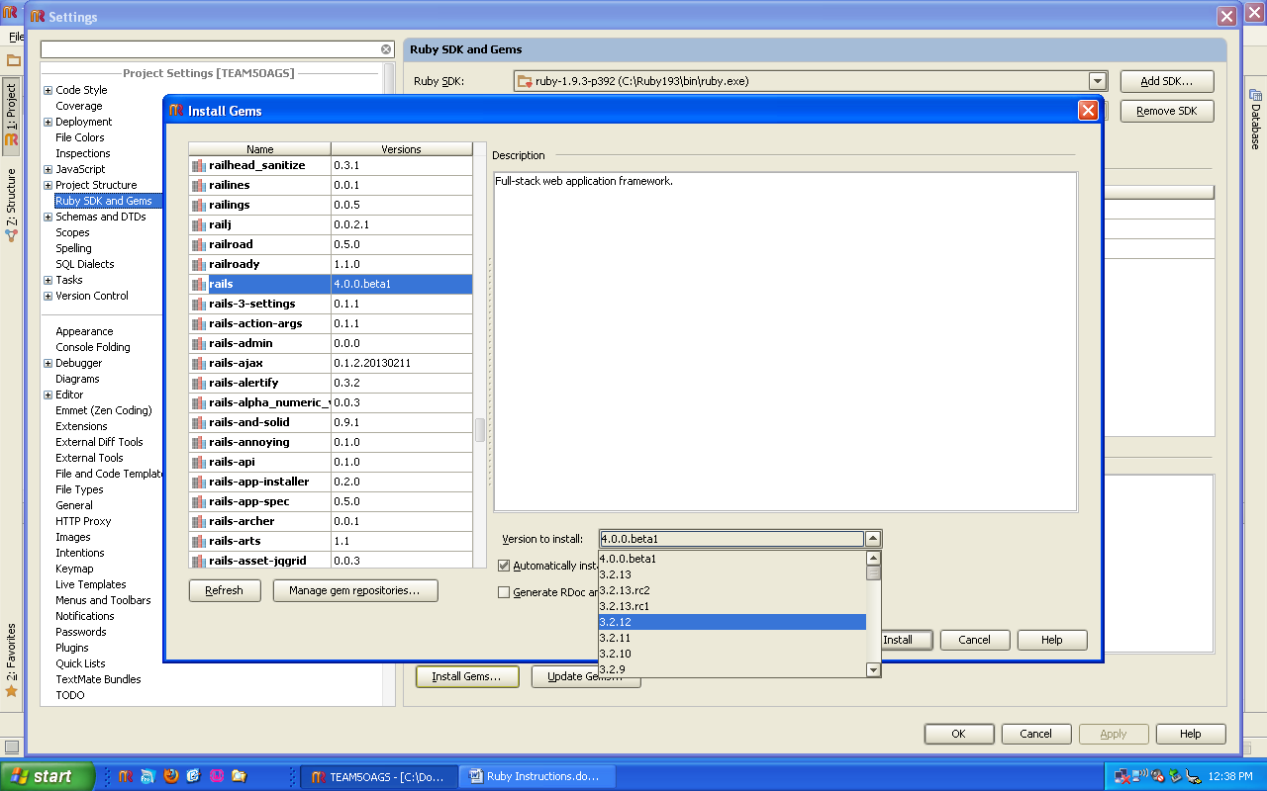

Before you click on install make sure you have rails and 3.2.12 selected as shown. If so, click on install.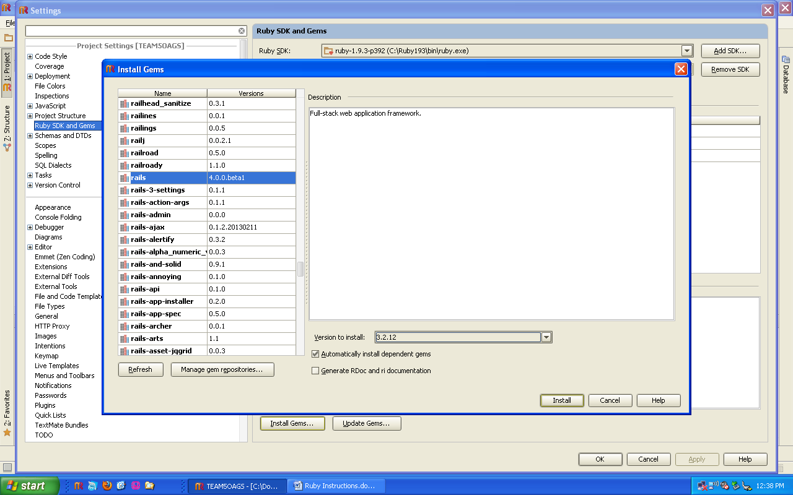

Screenshot of rails gem installing.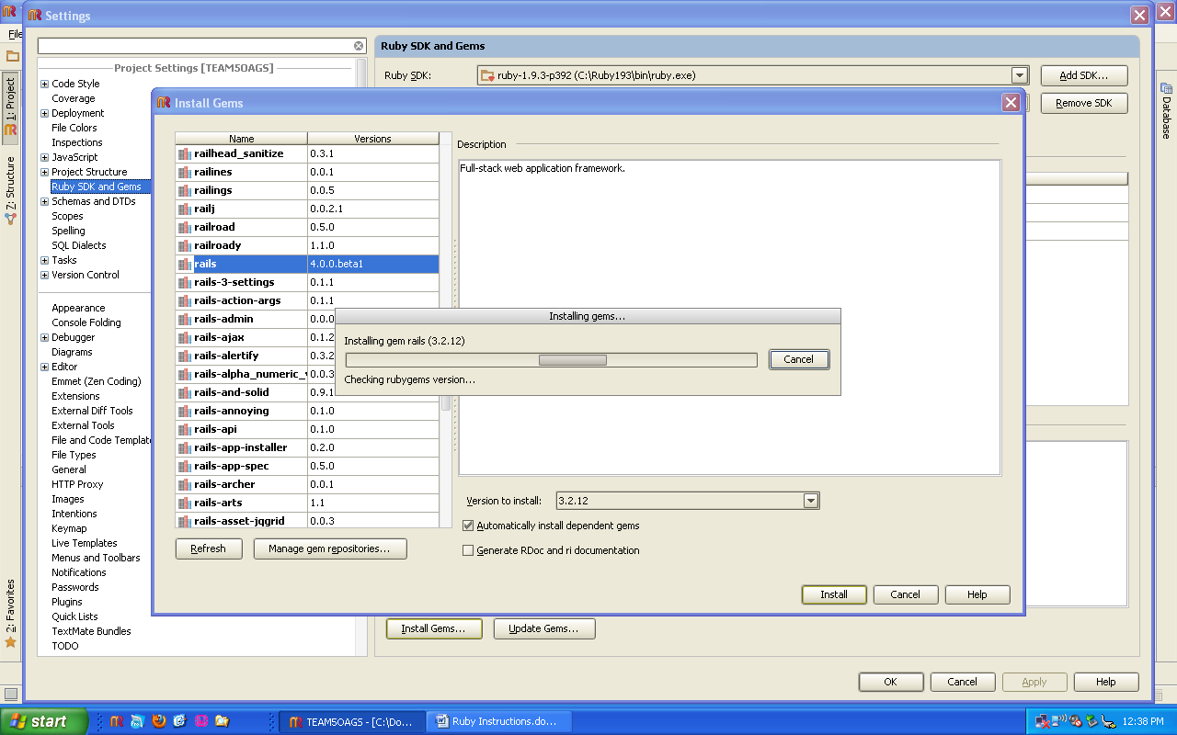

Next go to Tools🡪Bundler🡪Update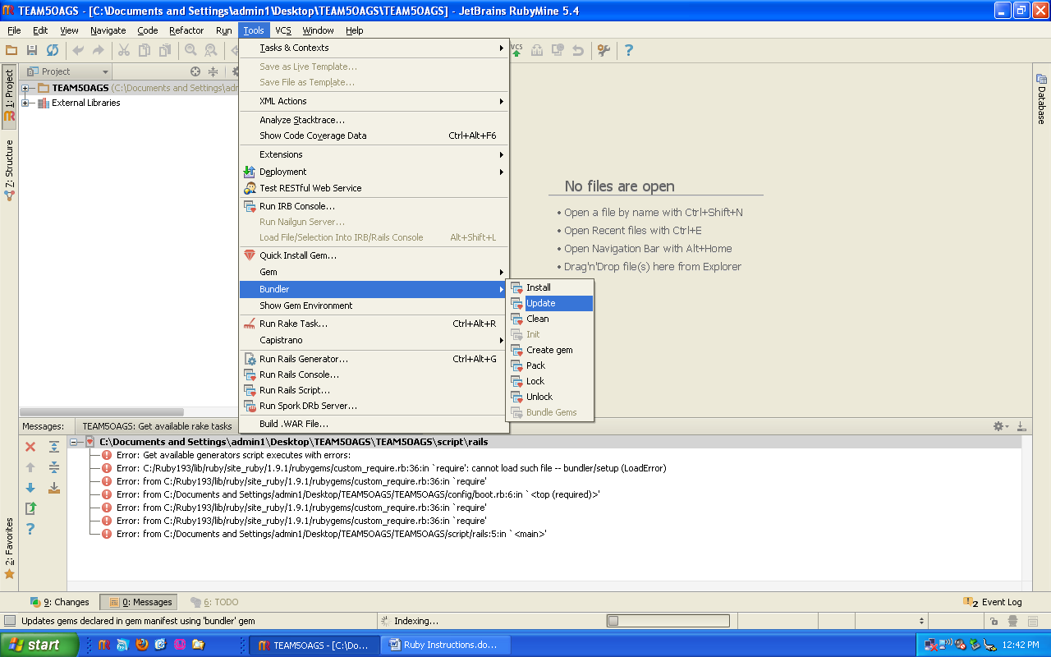

Do not type any additional arguments and click on update.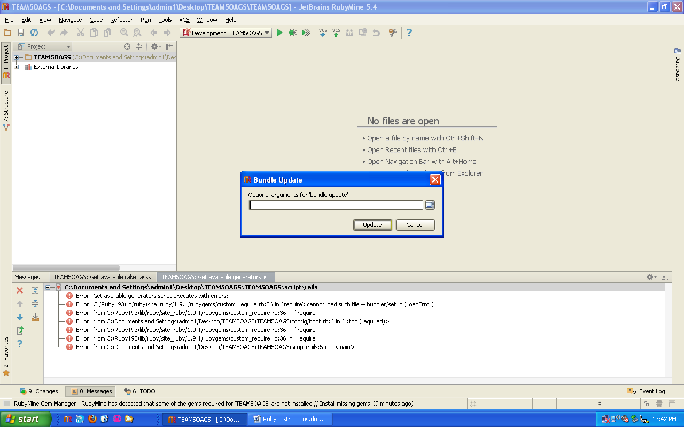

Screenshot of gems updating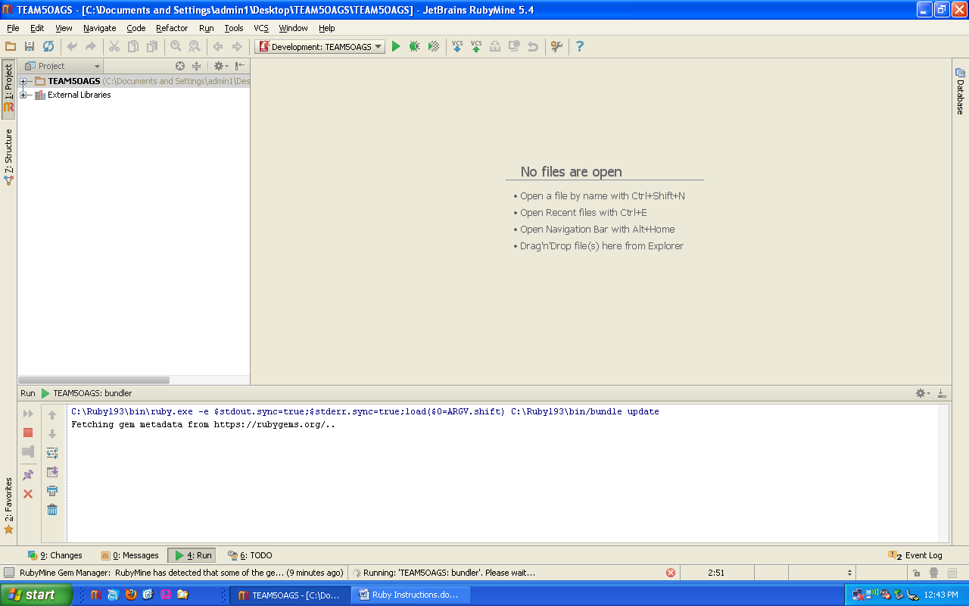

Screenshot of gems updating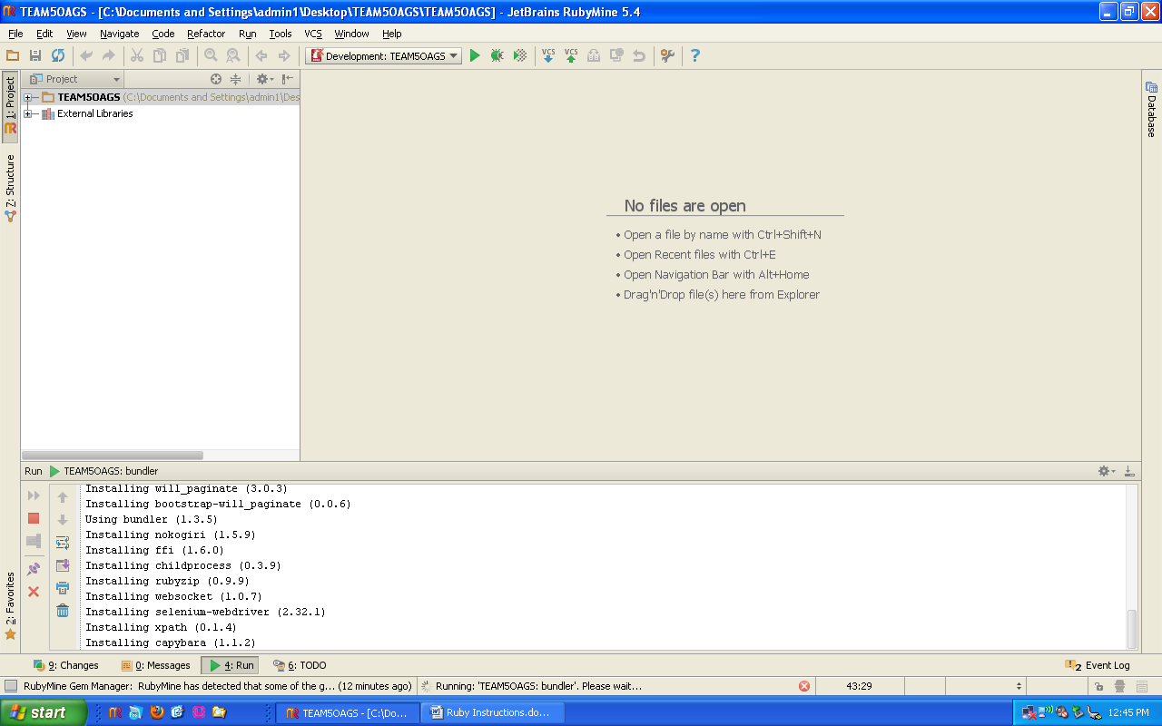

Screenshot of gem update finishing successfully.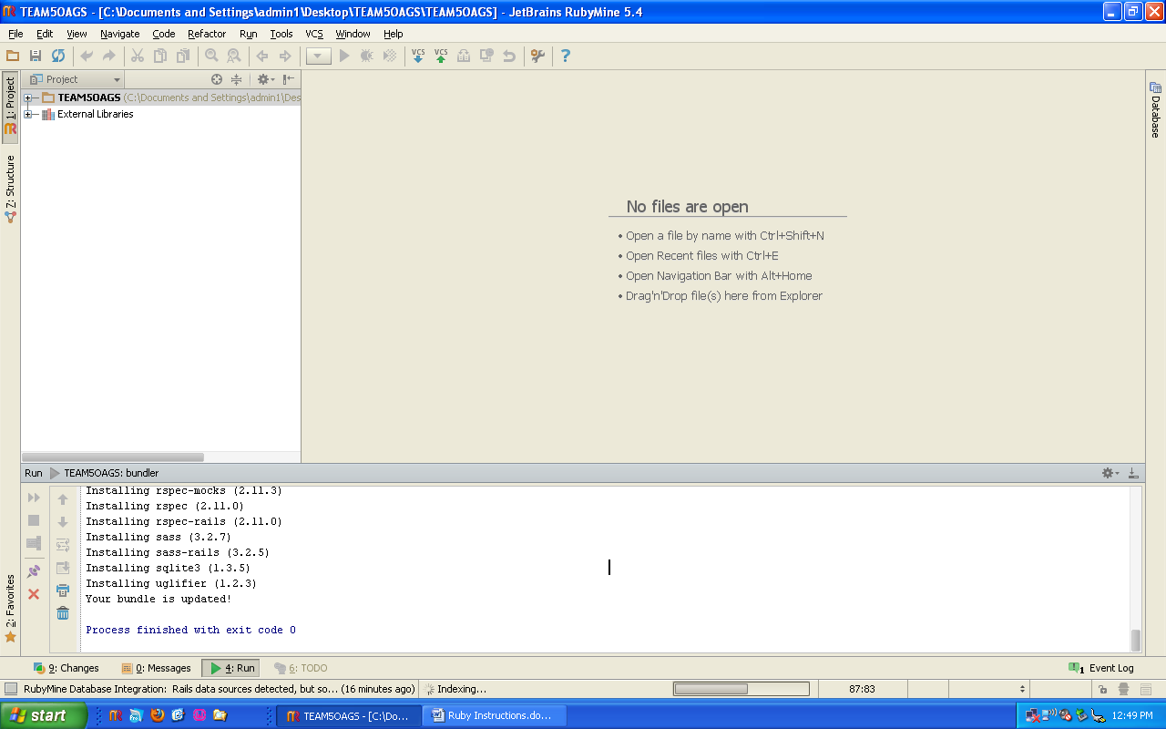

Next install the bundle. Navigate to Tools🡪Bundler🡪Install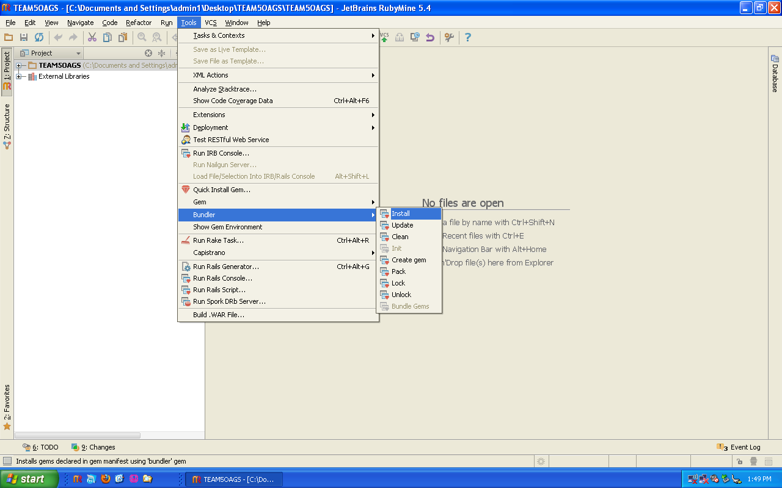

Leave the arguments blank and click on Install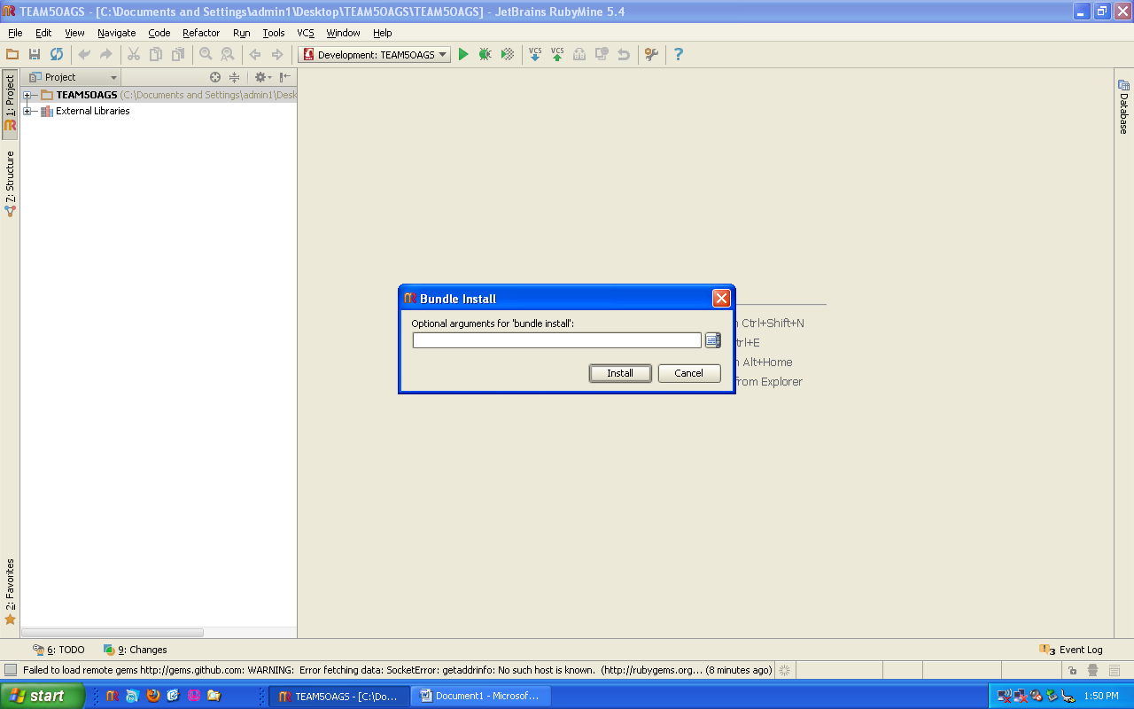

Screenshot of Bundle Install running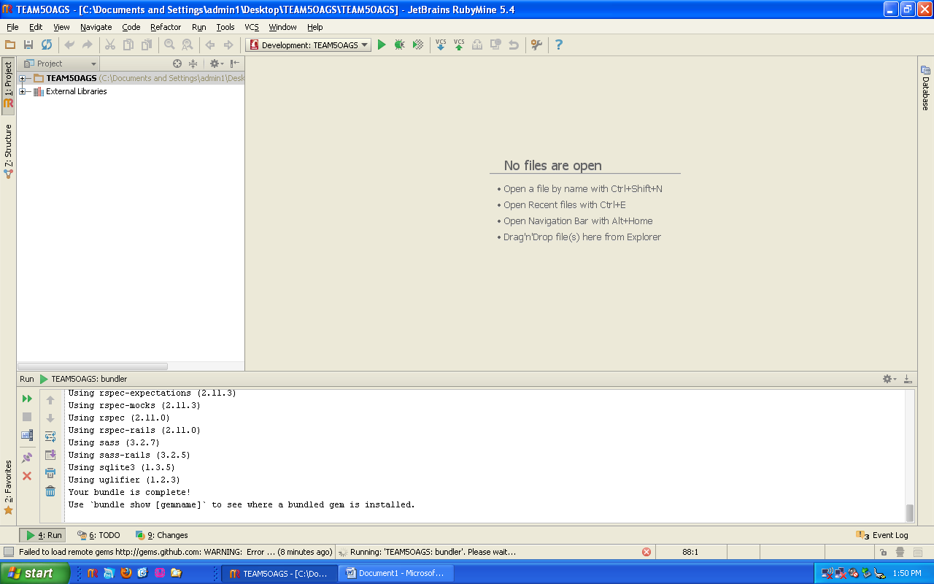

Next click on the green play button to start the rails server.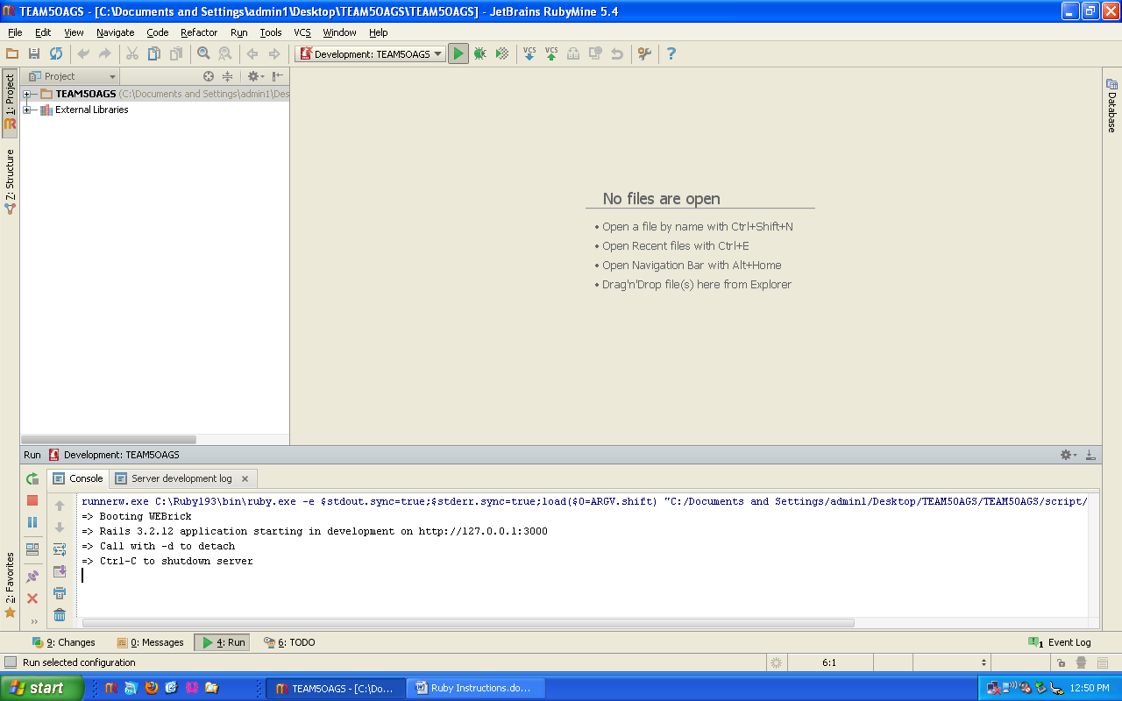

Next open your web browser and type http://127.0.0.1:3000 in the address bar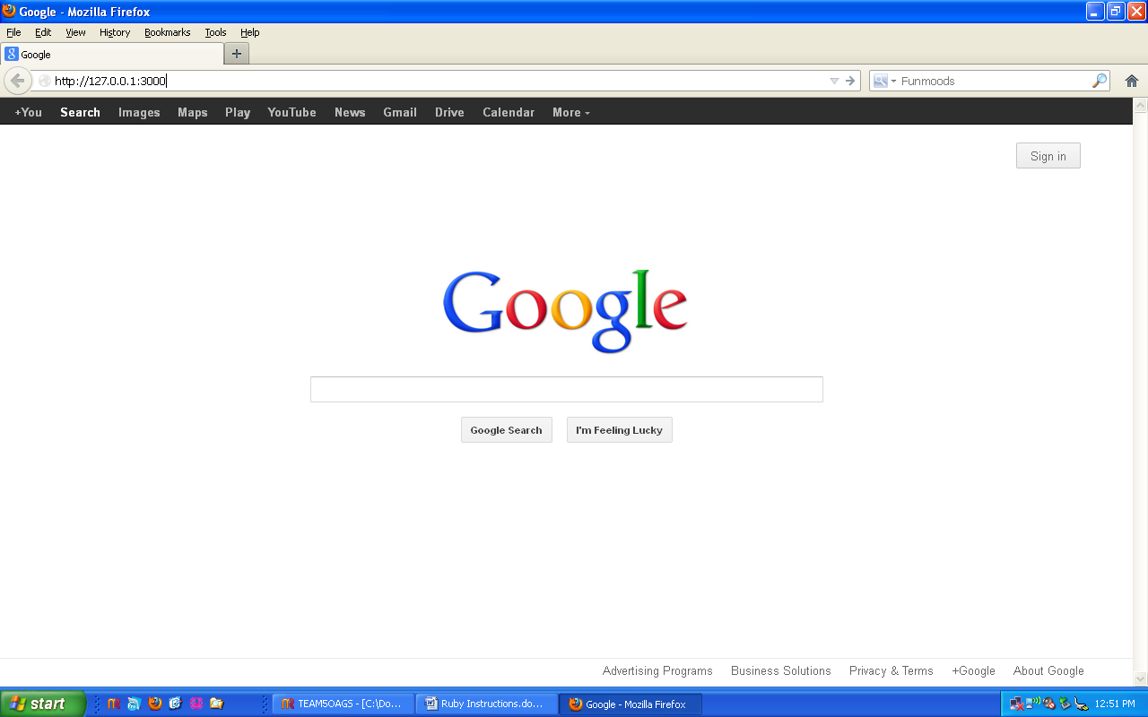

If it does not load right away give it a couple seconds, the WEBrick server is sometimes a bit slow to start. TEAM5OAGS page: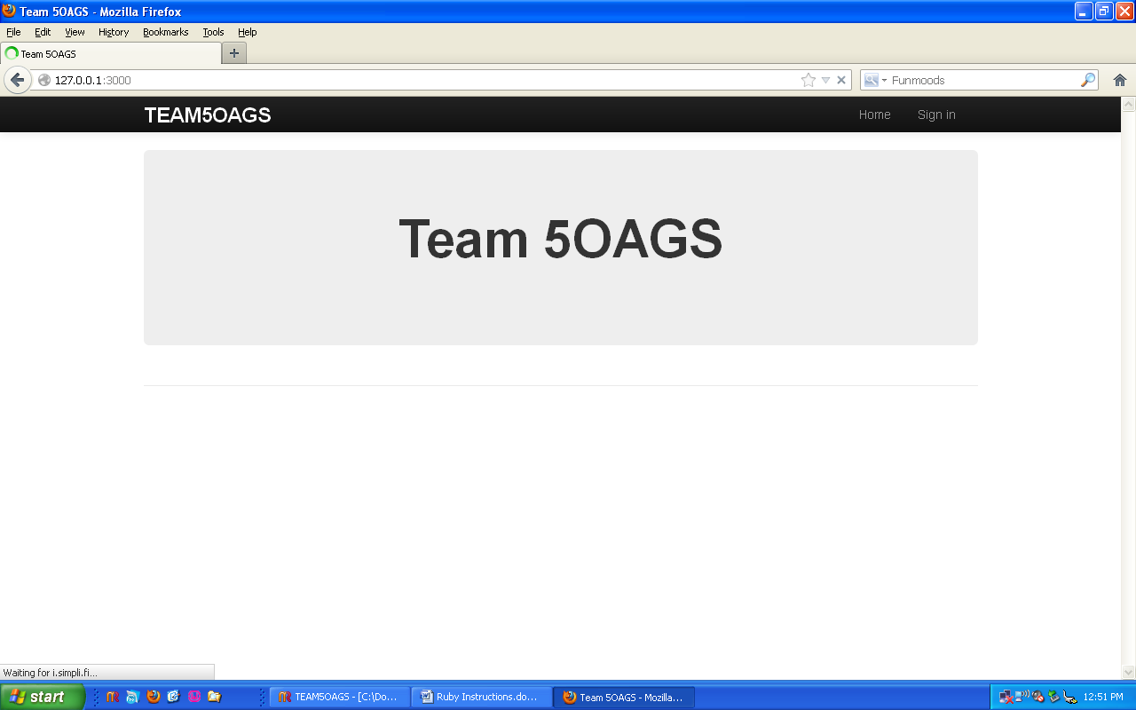

When done click on the stop button to stop the server.